Apache Kafka:

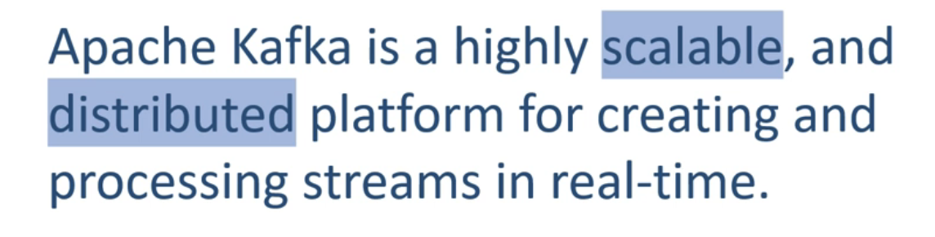

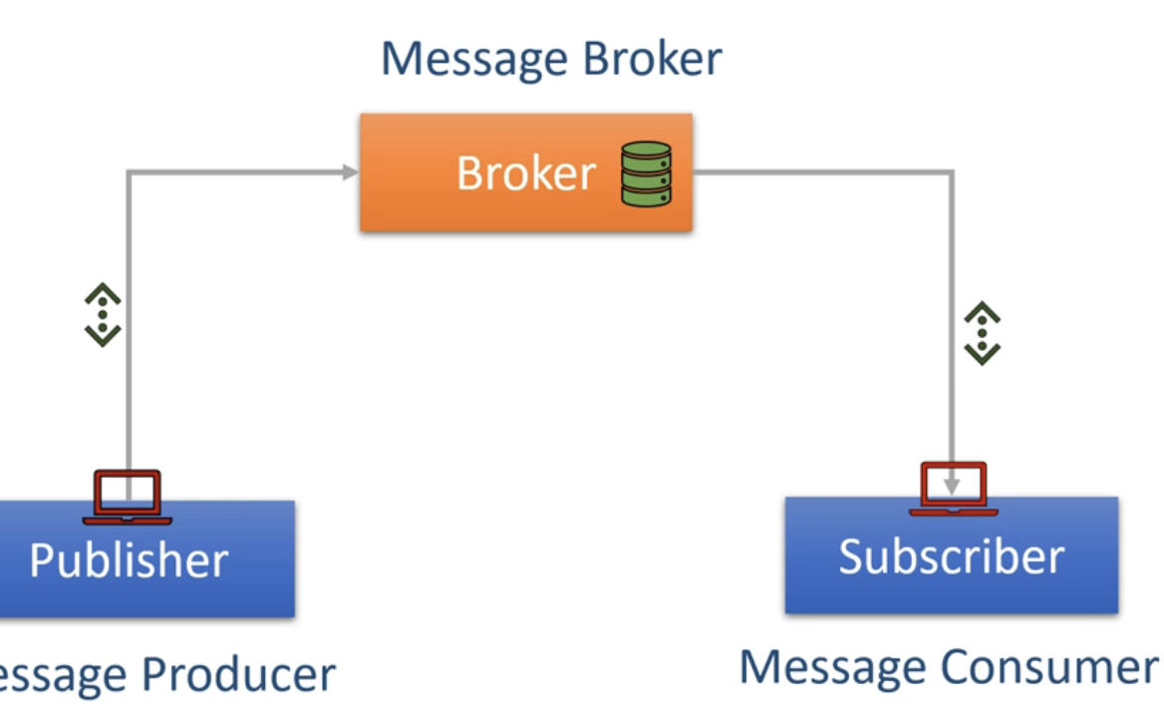

I'm going to explain it right here. A typical messaging system has got three components. Producer, Message broker And Consumer. The producer is a client application that sends data records. These data records are called messages. The broker is responsible for receiving messages from the producers and storing them into local storage. Finally, the consumers are again client applications that read messages from the broker and process them. In this architecture, the broker is in the center and acts as a middleman between producers and consumers.

Pub/Sub messaging system, where we create producer applications to send data as a stream. We install and configure Kafka server to act as a message broker. And finally, we create consumer applications to process the data stream in real-time.



It evolved from data integration solution

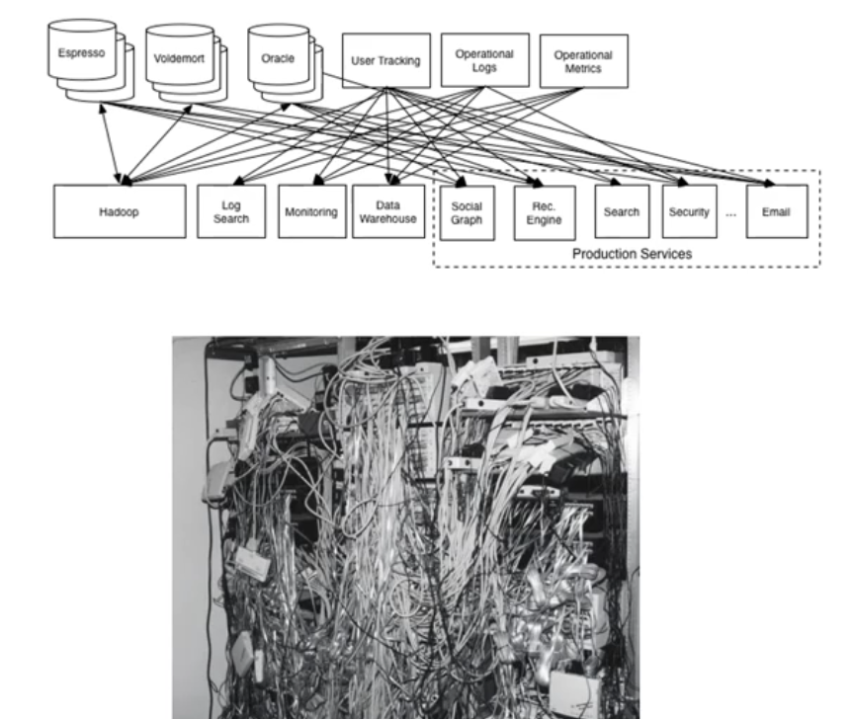

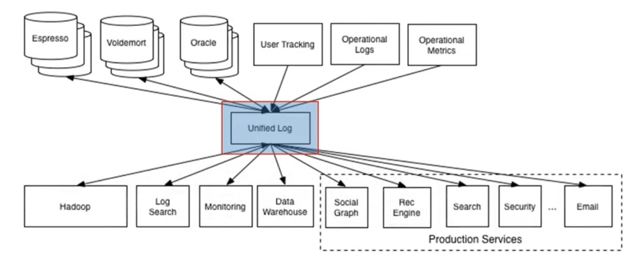

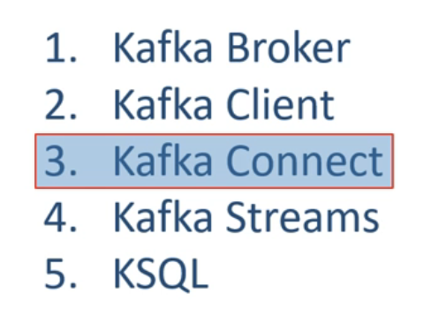

So to answer your question from 2011 to 2019 Kafka evolved as a set of five components. Kafka broker - Which is the central server system Kafka Client API - Which is Producer and Consumer APIs. Kafka Connect which addresses the initial data integration problem for which Kafka was initially designed. Kafka streams This one is another library for creating real time extreme processing applications. KSQL with KSQL Kafka is now aiming to become a real time database and capture some market sharing Databases and DW/BI space. Finally the last question of this lecture. Where does it fit into an enterprise application ecosystem? By adopting Pub/Sub semantics, Apache Kafka is becoming the circulatory system of your data ecosystem. In this case, just like your circulatory system carries blood. Kafka brings data to various members of the infrastructure. Kafka occupies a central place in your real time data integration infrastructure. The data producers can send data like messages, and they can send it to Kafka brokers as quickly as the business event occurs. Data consumers can consume the messages from the broker as soon as the data arrives at the broker. With careful design, the messages can reach from producers to consumers in milliseconds. The producers and consumers are completely decoupled, and they do not need tight coupling or direct connections. They always interact with the Kafka broker using a consistent interface. Producers do not need to be concerned about who is using the data, and they just send the data once without worrying about how many consumers would be reading it. Producers and consumers can be added, removed, and modified as the business case evolves. Great! That's all for the overview. See you in the next lecture. Keep learning and keep growing.

CoreComponents:

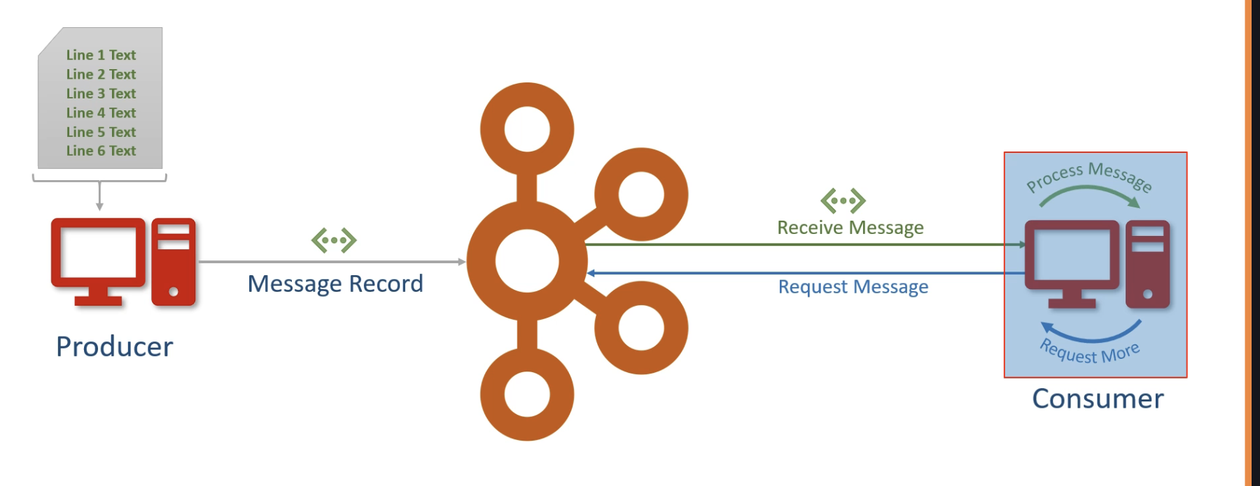

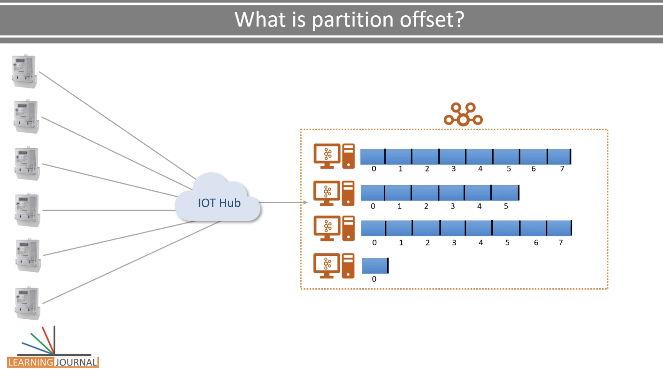

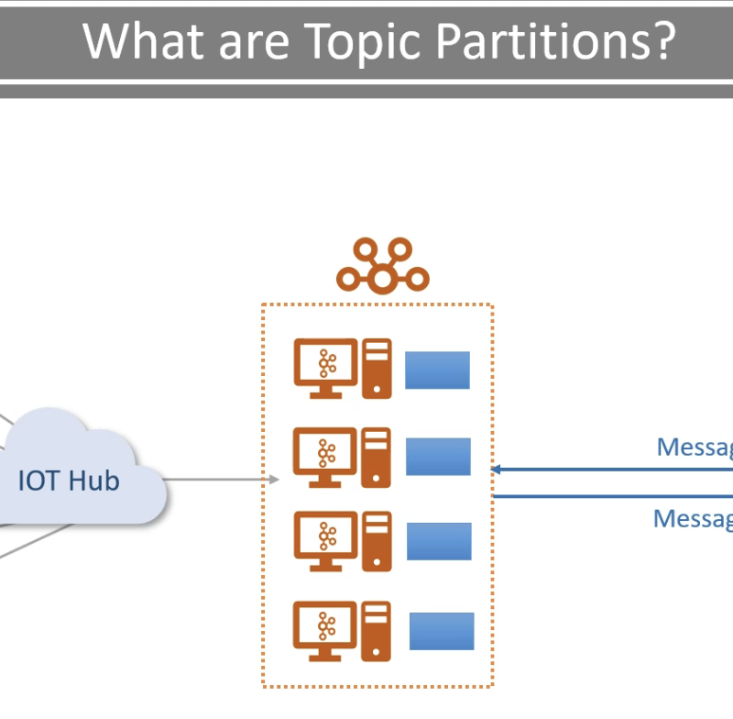

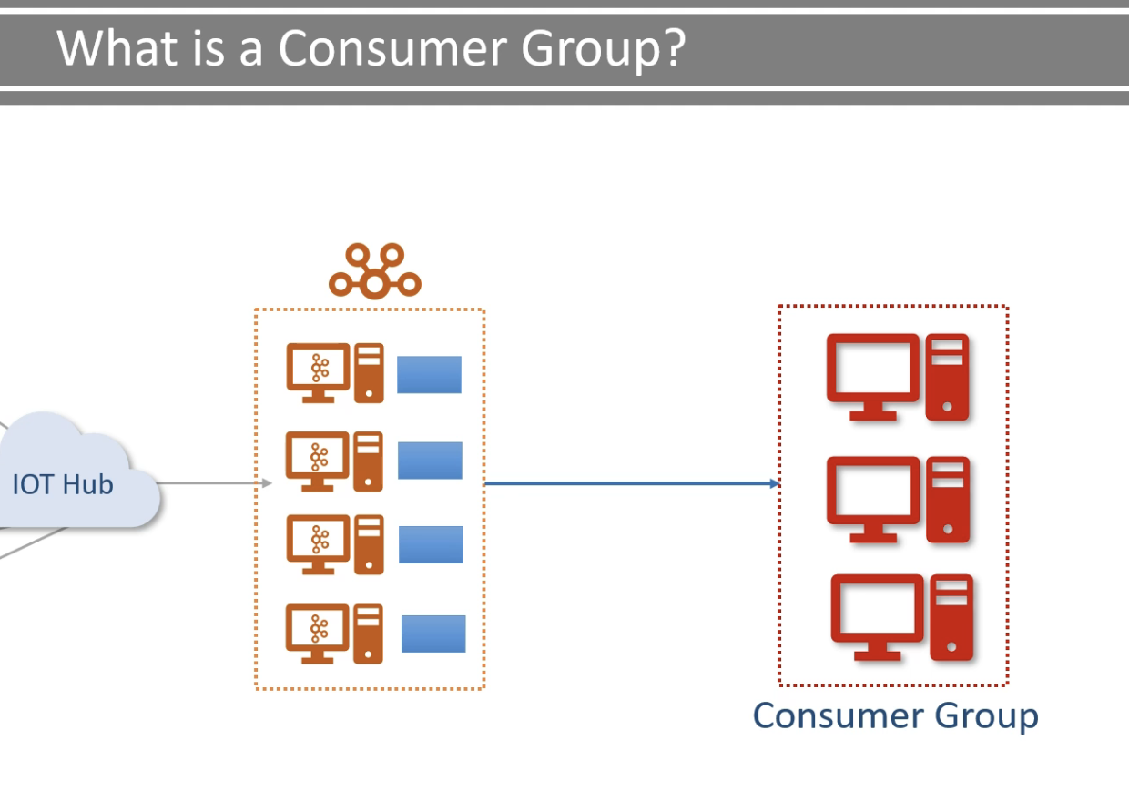

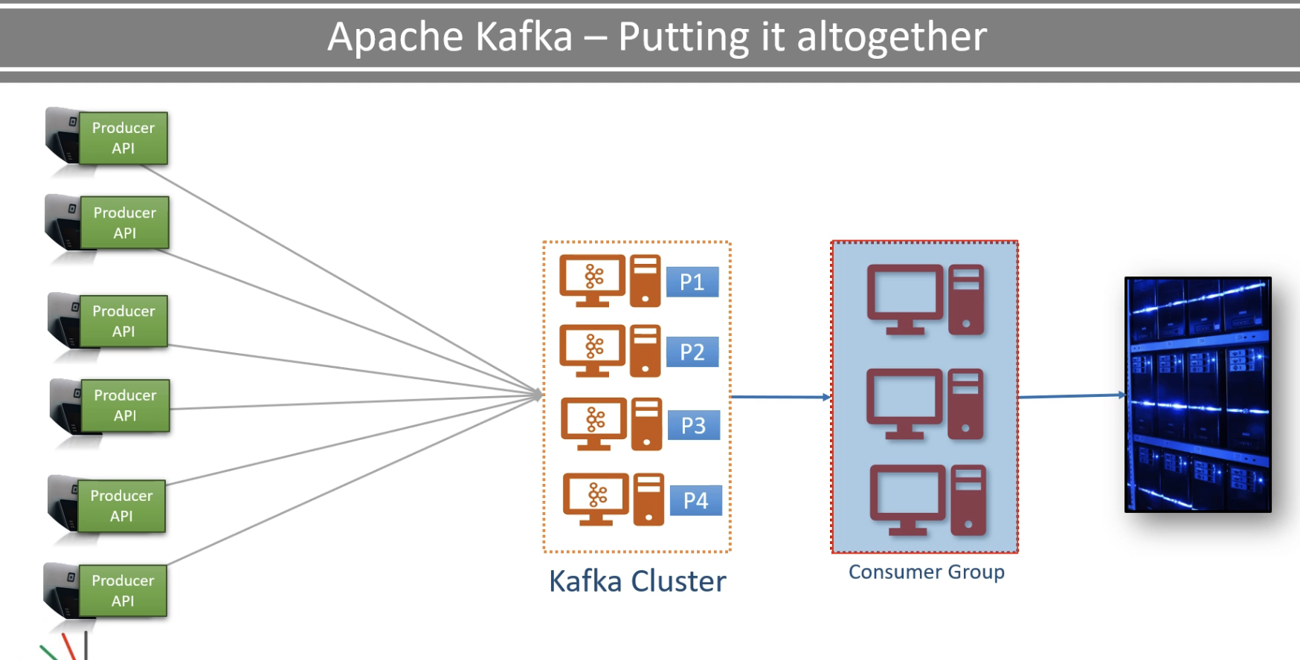

Welcome Back to Kafka Big Picture for Beginners. In the earlier lecture, I talked about five core components of Kafka ecosystem. In this lecture, I'll be explaining some fundamental concepts that are associated with Kafka. These are the core concept. And the rest of the training is built on your clear understanding of these terminologies and their meaning. So let's start. The first item is the producer. So what is a producer? A producer is an application that sends data. Some people call it data, but we often call them a message or a message record. Ultimately, it is a small to medium sized piece of data. The message record may have a different meaning and schema or record structure for us. But for Kafka, it is a simple array of bytes. For example, if I want to send a data file to Kafka, I'll create a producer application, and send each line of the file as a message. In this case, a message is one line of text, but for Kafka it is just an array of bytes. Similarly, if I want to send all the records from a database table, I'll post to each row as a message. Similarly if you want to send the result of a database query, you are going to create a producer application. The producer is going to fire a query against your database, collect the result and start sending each row as a message. So while working with Kafka if you want to send some data, you may have to create a producer application. You might find an out of the box ready to use producer which fits your purpose. But we'll talk about that situation later. The next item is the consumer. What is a consumer? The consumer is an application that receives data. If the producers are sending data they must be sending it to someone. Right? The consumers are the recipients. But remember, the producers are not going to send data directly to the recipients. They just send it to the Kafka server. And anyone interested in that data should come forward and consume the data from the server. So an application that is going to request data from the Kafka server is up consumer. And they can ask for the data sent by any producer provided that they have permissions to read it. So if we come back to the data file example, when I want to read the data file sent by a producer I'll create a consumer application. Then I'll request the Kafka server for the data. The Kafka server will send me some messages. I guess you remember that each message record is a line of text from the data file. So, the consumer application will receive some lines from the Kafka server. It will process them and again request for some more messages. This goes in a loop. The consumer keeps asking for the messages, the server keeps giving new records, and this goes in a circle as long as new messages are arriving at the kafka server. Now it's up to the consumer application on using the data. They might want to compute some aggregates and send some alerts. That part is up to the consumer application. The next item in our list is the broker. What is a broker? The broker is the Kafka server. It is just a meaningful name that was given to the Kafka server, and this name makes sense as well. Why? Because all that the server is doing is to act as a message broker between producer and consumer. I mean the producer and consumers do not interact directly. They use the Kafka server as an agent or a broker to exchange messages. Right? Great! What is next? What is a cluster? If you have any background in distributed systems, you already know that a cluster is a group of computers acting together for a common purpose. Kafka is a distributed system, and hence the cluster means the same thing for Kafka. So the Kafka cluster is a group of computers, each running one instance of the Kafka broker. That's all. Great! The next item is the topic. What is a Topic? We already learned that the producer will be sending data to the broker. On the other side, the consumer will be asking data from the broker. But the question is, what data or which data? The broker might say, Guys, I am collecting data from multiple producers. Which one do you want? OK. Give me the data sent by the smart meter producer. Well the smart meter producer is sending three different types of data. current-load - sent every minute. consumed-units This one is sent every hour. input-current-fluctuations This one is sent as and when it happens. Which one do you want? Well, give me the current load messages. OK so you are looking for a current load message. That's great. But we have a bunch of smart meter producers, and all of them are sending the current load messages. So which one of those are you interested in. Gosh! That's too much confusion. We must have some standard methods to cut down these back and forth questioning, right? And that's where we have the notion of Topic. So the topic is an arbitrary name given to a data set. You better say - it's a unique name for a data stream. If you're coming from a database background, you can also think of it as a database table. Creating a topic is a design time decision. So when you are designing your application, you as an architect are responsible for creating one or more topics. Once your topic is there, the producers and the consumers are going to send and receive data by the topic. Now let's come back to our smart meter example. Let's assume I created three topics. Current-Load-Topic, Consumed-Units-Topic, Input-Fluctuations -Topic. When my smart meter producers are sending data, they'll send all the current load messages to the current load topic. Similarly they'll be sending consumed the units and input fluctuations to their own topics. Now you look at the consumer to broker communication. The consumer application will request like this. Give me all the data that you received in the current load topic. Simple isn't it? The broker knows the topic, and it won't have any further questions. In the database world, you can think of the Kafka topic as a table. Producers can insert new records in the table and hence to the topic. The consumers can read those records from this same table, and hence from the same topic. Right? But remember, all the communication happens via a broker. There is no direct interaction between producer and consumer. Great! The next item in our list is the partitions. So what are topic partition? By now, you learn that the broker would store data in the topic, and the topics are just like a database table. This data could be massive. It may be larger than the storage capacity of a single computer. Think of the hundreds of thousands of smart meters sending current load every minute. In just a few hours, you are going to collect several terabytes of data. Isn't it? So the broker is going to face a storage capacity challenge. One obvious solution is to break the topic into multiple smaller parts and distribute it over multiple computers in the Kafka cluster. We already learn that Kafka is a distributed system, and it runs on a cluster of computers. So it is evident that Kafka can easily break the topic into smaller partitions and store those partitions on different machines. This approach will solve the storage capacity problem, and that's where the topic partition means. A small and independent portion of the topic, right? However you might have another question. How will Kafka decide the number of partitions for a topic? I mean, some partitions might be reasonably large, and others may be comparatively small. For example the current load topic is receiving data every minute and consume units units are collecting data every hour. So the current load topic is going to be huge whereas the consumed units will be a smaller topic. So the question is this how Kafka would know if the current load topic might need hundred partitions and the consumed units topic might need just 20 partitions. Well the answer is simple. Kafka doesn't make that decision. The number of partitions in our topic is a design decision. So we as an architect are going to decide the number of partitions for each topic. When we create a topic we need to specify the number of partitions that we need, and the Kafka broker will produce it. That's all. But remember, the partition is the smallest unit and it is going to be sitting on a single machine. You cannot break it again, so you must be doing some meaningful estimation to decide the number of partitions for each Topic. Great! The next item is the Offset. What is partition Offset? Well, the offset is a simple thing. It is a unique sequence ID of a message in the partition. The sequence ID is automatically assigned by the broker to every message record as it arrives in the partition. Once assigned, These ideas are not going to change. They are immutable. So when the first messages are stored in a partition, it gets an offset ID as zero. The next one gets one then two and so on. This sequencing means that the Kafka stores messages in the partition, in the order of arrival. And the offset ID is clearly an arrival order number. But remember these offsets are local within the partitions. There is no global ordering in the topic across partitions. So if you have three partitions in a topic within each partition, the offset is going to start from zero and increase by 1. So if you want to locate a specific message, you must not read things. Topic name, Partition number and then the offset number. If you have these three things you can directly look at a message in the Kafka cluster. Great. We are almost done except the last thing. What is a consumer group? We already understand the consumers. But what is a consumer group? Well it is a group of consumers. So multiple consumers can form a group to share the workload. You can think of it like there is one big massive work, and you want to divide and assign it in smaller parts among multiple people. So you'll create a group and the members of the same group are going to share the burden and accomplish the bigger task together. That's what the consumer group is. Let me put up an example from the retail industry. In this example, we will be putting everything all together and stitching the whole story. It's gonna be an exciting example, so pay some attention to it. Let's assume we have a retail chain. In every store, You have a bunch of billing counters. You want to bring all of your invoices from every billing counter to your data center. Since you learned Kafka and you found Kafka to be an excellent solution to transport data from your billing locations to your data center. You decided to implement it. The first thing that you may want to do is to create a producer at every billing location. These producers are going to send the invoices as a message to the Kafka topic. The next thing that you want to do is to create the consumer. The consumer is going to read the data from your Kafka topic and write it to your data center. Simple, I'm not assuming complex processing here. All we want to do is to bring the data to the data center as quickly as we can. This whole thing looks like a perfect and straightforward solution. Right? But there is a small problem. Think of the scale. You have hundreds or maybe thousands of producers pushing data into a single topic. How do you handle the volume and velocity at the broker? But you learned Kafka exceptionally well, So you decided to create a large Kafka cluster and partition your topic. Correct? So your topic is partition and distributed across the cluster. Now every broker has got a topic partition so it can take the data from a producer and store it in the partition. So on the data source side you have hundreds of producers and a bunch of brokers to share the workload. Right? But what does it mean. It means the topic partitions are not only a solution to increase their storage capacity but also a method to distribute the workload. Kafka topic partitions are the core idea of making Kafka are distributed and a scalable system. You will learn more about it. But at this stage, I just wanted to stress on one thing. Partitions are the most valuable concept to understand how Kafka behaves as a distributor and a scalable platform. Remember it. Great. So we made our solution is scalable from the left side. What about the right side? We have a single unfortunate consumer. How is it going to handle so much incoming data alone? There comes the consumer group. You'll create a consumer group, start multiple copies of the consumer application in the same group, and let them divide the workload. Simple isn't it. Well that's good. But how do we divide the work? That's not a difficult question, right? Let's say I have 500 topic partitions. And I'm starting hundred consumers in a group. So each consumer will take five partitions and altogether they will be processing 500 partitions. Right? We will monitor the load for some time and see if a single consumer can handle five partitions. If not we can start some more consumers in this same group. We can go up to 500 consumers so each consumer will have just one participant to read, right? If you followed this example correctly, you would clearly understand that the topic partition is a tool for scalability and you should also notice that the maximum possible parallel consumers are limited by the number of partitions in that topic. Kafka doesn't allow more than one consumer to read and process data from these same partitions simultaneously. And this restriction is necessary to avoid the double reading of records. Great. I hope you learned the most critical core concepts of Apache Kafka. And now, you are familiar with the terminology that is going to be extensively used in this course. See in the next lecture. Keep learning and keep growing.

Install Kafka:

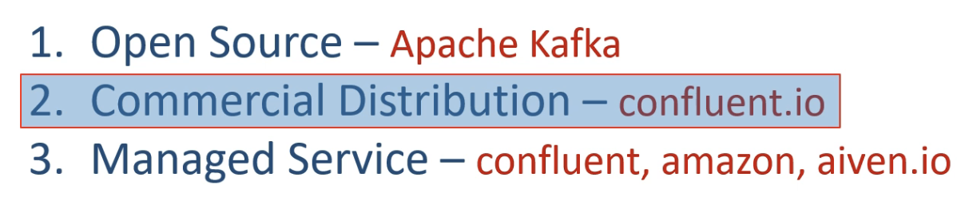

Welcome back. In this lecture, we are going to set up a single node Kafka on your local machine. But before that, let me add some contextual theory. Kafka comes in many flavors, and you can classify them into three categories. The first one is the open source version of Kafka. You can download it from the Apache website, install it, use it and manage it yourself. If you're getting into some operational issues or open bugs, need to upgrade Kafka versions, or facing some infrastructure problems. You are all alone and expected to develop in-house expertise to handle it. The point is straight. Your organization is unlikely to use open source distribution unless you have a bunch of Kafka admins and infrastructure experts who understand the in and out of Kafka cluster. And that's hard to find. The second option is to get a commercial distribution that comes with a bunch of tools and utilities to manage your day to day operations and monitor your cluster. Your commercial vendor is going to employ a bunch of well-trained and highly skilled support professionals for you. This option comes with a cost to your organization. However you are most likely to work on these kinds of setups. Confluence Kafka is one such commercial distribution, and it is the most popular one. Conflict also offers a community addition without any cost. And that's what we are going to use in this course. Why Confluent Kafka and Why not Apache Kafka? You already know the answer. Because you are most likely to see conflict Kafka in your production environment. So we are going to use the same for our learning. The third option is a fully managed Kafka service in the cloud. In this option, you do not need to download, install, run operate or maintain anything related to the Kafka cluster. Just use the cluster for producing and consuming data. All the infrastructure headache is taken care of by the managed service provider. This option is the simplest way of using Kafka for your projects and comes with different payment plans. Confluent is also a managed service provider, and there are others as well including Amazon and Aiven.io. However, you should also notice that all these options are to get a Kafka cluster. You still need to develop applications for creating and processing data streams. Great. So with that background set, let's download Confluent Kafka community edition and setup it on your local machine. Go to the confluent.io and hit the download button. Scroll down, and you will see a link to download the community edition. Uncompress the download file, and you should see a directory with the following content. And that is all. Your download is a pre configured single load Kafka cluster. Since Kafka is a JVM based application, all you need to make sure that you have got Java installation on your machine. And you are ready to start your Kafka services. You can check your Java installation using the following command. Kafka comes with a bunch of command-line tools, and you can find them in your bin directory. Let me show you. These are all shell scripts. And you can find the compatible windows batch files in the windows directory. I'm on windows machine so I'm going to use Windows batch files. If you are doing it on Linux or Mac, then you should be using these shell scripts. Great. So we are all set to do the real thing that we wanted to do in this video. Start a single node Kafka cluster, right? Let's do it. Starting a Kafka cluster is a two step process. The first step is to start a zookeeper server and you can start using the zookeeper-server -start script. However, this script also takes one mandatory argument. A zookeeper configuration file. I talk about the configuration file in a later video, but your download already comes with the ready to use zookeeper configuration file. configuration file. You can find it in etc\kafka\ directory, and the file name is zookeeper.properties. Oops! If you get the same error, then your confluent Kafka download has got a broken script for windows. Let's fix it. Open Kafka-run-class.bat file. Search for text "Classpath addition for the core." Copy paste the following content above the selected line. Save the file and try again. Great. So your zookeeper is now running. The next thing is to start Kafka broker. Minimize the zookeeper window and start a new command window. You're gonna start Kafka broker using Kafka server to start a script. This one also needs a configuration file which you can find in the, etc\kafka directory. Let's run it. Great! Kafka server ID 0 started. That's your Kafka Broker ID. You are now ready to play with this single node Kafka cluster. We are done. Do you have a question. I have one. What is zookeeper, by the way? We knew Kafka brokers, but where did the zookeeper come in between. So zookeeper is a kind of database where Kafka brokers would stored a bunch of shared information. And it is used as a shared system among multiple Kafka brokers to coordinate among themselves for various things. Kafka community has already announced that they are going to retire the zookeeper in the coming days. But until then, Kafka needs zookeeper for coordinating things among the brokers. And you must have it running even if you have got a single broker. More on zookeeper and its exact role will come in a later video. Great! So we have seen the Confluent Community edition. However, if you wanted to use the open source edition, you can do that as well. The steps are almost the same, with minor differences. Let me quickly demonstrate that well. Before we start working with another version of Kafka, let me shut down the current version. If you don't do this, you are going to face port conflict issues because the open-source version is also going to use these same ports. Great! Go to the Apache Kafka website. Hit the download button. We are looking for a binary download. Click any one of these, and your download should start. Uncompress your downloaded file, and you should see the following directory structure. The directory structure looks similar to Confluent Kafka, right? There are few differences, and you will notice that some directories are missing from the open-source version. But nothing to worry. The open source version also carries this same thing. It is just the directory structure that is different, and confluent brings a few additional capabilities that you are going to understand as we progress with the course. So, what do we want to do? Two things. Start zookeeper, and then Start Kafka broker. That's what we have done with Confluent Kafka, right? Let's start the Zookeeper. Okay. So here is the command which we used to start this zookeeper. This command remains the same except for the zookeeper configuration file location. Let me change it. That's all. Let me start the zookeeper. Great! It is running now and listening to port 2181. That's the default zookeeper port. Let me start a new command window and start the Kafka broker. So, here is a command. This one also remains the same except the broker configuration file location. Let me change it. Good. Hit the enter key, and it should start the Kafka Broker. Started. Right? So in this lecture, we learn to start a single note Kafka broker using two different types of distributions. Confluent Community Edition and Open Source Edition. Once you have the zookeeper and Kafka running, leave these windows open, and you are ready to start using Kafka cluster for all your hands-on activities. If you are willing to explore the Kafka managed services, you can try accessing Confluent Cloud or Aiven Kafka. That's all for this lecture. See you again in the next video.

Start Kafka Server:

bin/zookeeper-server-start etc/kafka/zookeeper.properties

Send Kafka Message:

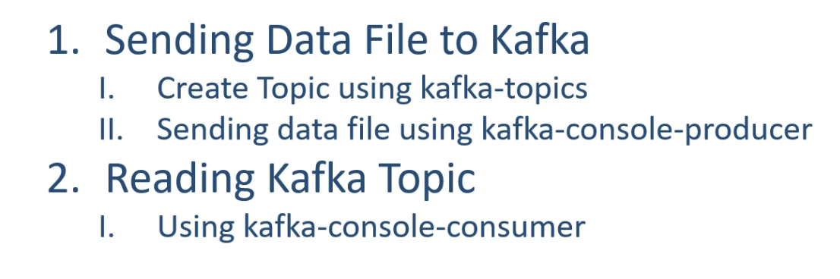

Welcome back. In this lecture, we are going to see a Kafka producer and a consumer in action. I'm not going to write a Kafka producer or a consumer application. Instead, for this first producer/consumer demo, we are going to use an out of the box console-producer tool and a console-consumer tool. So let's get this started. So, we want to do the following things in this demo. I have a data file. It is a CSV file that contains some data. And I want to send it to the Kafka cluster. However a producer should always send data to a Kafka topic. So we will do it in two steps. The first step is to create a topic. And we will be using the Kafka-topics command-line tool for creating it. Then as a second step, we will be sending all the data from the file to the Kafka cluster. And we will be using the Kafka console producer tool for doing this. Once the data starts coming to the Kafka, we want to move to the next step. The next step is to consume the data from the Kafka topic. So we will be running a Kafka console-consumer tool to read all the data from the Kafka topic and display it to the console. Great. Let's do it. We are going to be using the Kafka topics tool for creating a topic. The name of the topic is "test," right? While creating a topic, you should also define the number of participants in the topic. But the question is this. How many partitions? Well, there are two evaluations. Storage requirement, and Parallel processing requirement. I'm going to send a small data set for this topic. So we are not going to consume a lot of space, and the entire data will easily fit into a single broker. So, there is no storage concern. I'll be reading this topic using a single consumer. That is all. So, there is no parallel processing requirement. The point is this straight. A single partition will do the job. Now the next mandatory thing is to specify the replication-factor. The replication-factor is the number of copies of each partition. You can create two or three copies giving a higher replication factor. Why multiple copies? Well, that's a fault tolerance feature. The copies are stored at different brokers. And if one broker is down, then we will have another broker with a copy of the partition. So, your consumers can still read the data from the cluster even if one or two brokers are down. However, in our case, we have a single broker, and it doesn't make any sense to have two or three copies. So let me set the replication factor as one. Finally, we are going to create a topic in the cluster, right? So we need to tell the cluster coordinates. This command takes the cluster coordinates as bootstrap-server, and the value is the IP and the port. The IP is the Kafka broker IP or hostname. And the port is the Kafka broker listener port. And 9092 is the default value. Let me run it. Then the topic is created. Now we are ready to send the file data. We are going to use Kafka- Console-producer to send data to the topic named "test." We also need to give the cluster coordinates. And for this tool, it is provided as a broker-list. The value is the same. Kafka broker hostname or IP and the listener port. Unfortunately, the two commands would call the same thing differently. The topic tool calls it bootstrap-server, and the producer calls it the broker-list. But the value is the same. Anyways, the Kafka-console-producer can take the inputs from a file. So, we are going to redirect the content of the data file. Good. The final step. We are going to use the Kafka-console-consumer tool to read the same topic from the same cluster. But we want to read the topic from the beginning. Let's run it. Good. You've got all the records reaching the consumer. If you send one more file. It will immediately come here. So, what we did? We simulated the following. We have a Kafka cluster in the center. It was a single node Kafka cluster, but it could have been a 50 node cluster in more complex scenario. Right? We had some data files on a remote machine. Well, we did it on the same computer. But it could have been a remote device that is too far from the cluster and connected over TCP/IP network. We sent those files to the Kafka broker, and we use them off-the-shelf Kafka producer application. We could have written a custom Kafka producer, but Kafka console producer is good at sending data files. So there was no need to create a new producer. On the other side, we had a consumer application that was reading the data and processing it. Well, the processing was too simple. Just displaying it on the console. But you can have a better Kafka consumer doing some meaningful things, right? This consumer was also sipping on this same machine. But this guy may also have been away from broker reading data over TCP/IP network. Right? That's all for this lecture. See you again in the next video. Keep learning and keep growing.

Start Zookeeper:

bin/zookeeper-server-start etc/kafka/zookeeper.properties

start Kafka Broker:

bin/kafka-server-start etc/kafka/server.properties

Create Topic:

bin/kafka-topics --create --topic test-topic1 --bootstrap-server localhost:9092 --partitions 5 --replication-factor 3

Produce Message from File:

bin/kafka-console-producer \

--broker-list localhost:9092 \

--topic test-topic < path/to/your/file.txt

Consume message

bin/kafka-console-consumer \

--bootstrap-server localhost:9092 \

--topic test \

--from-beginning

To run Multiple Kafka Brokers:

Create 3 server files

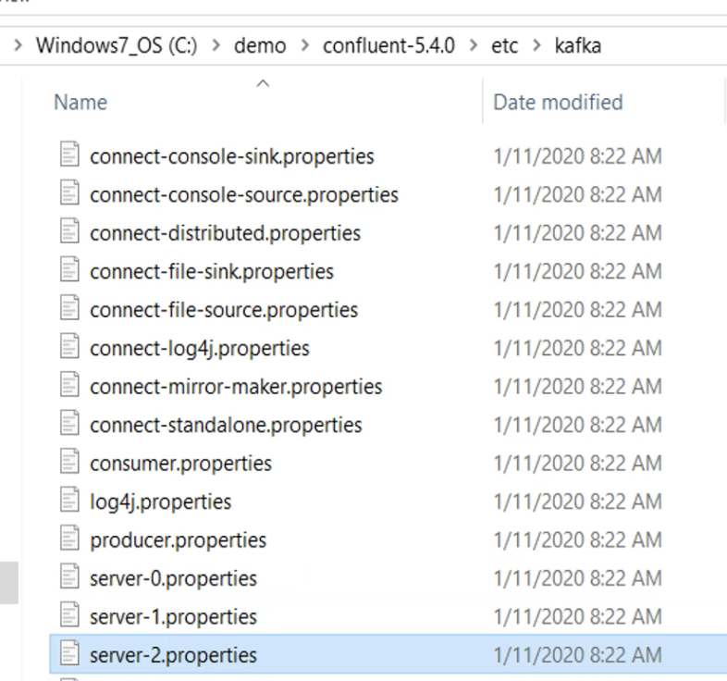

Change broker id for each and listeners and log dir which is the place where kafka stores data

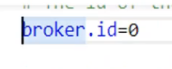

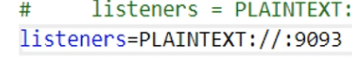

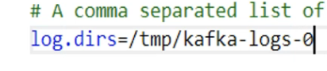



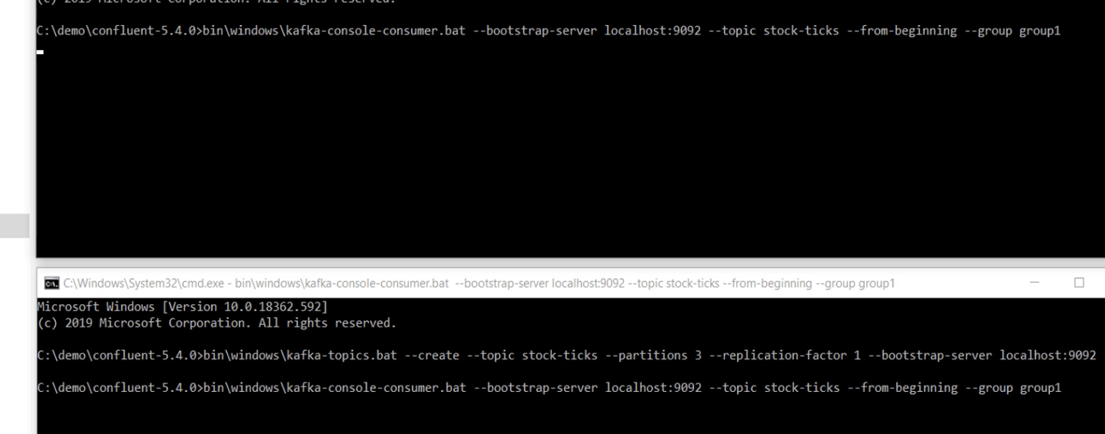

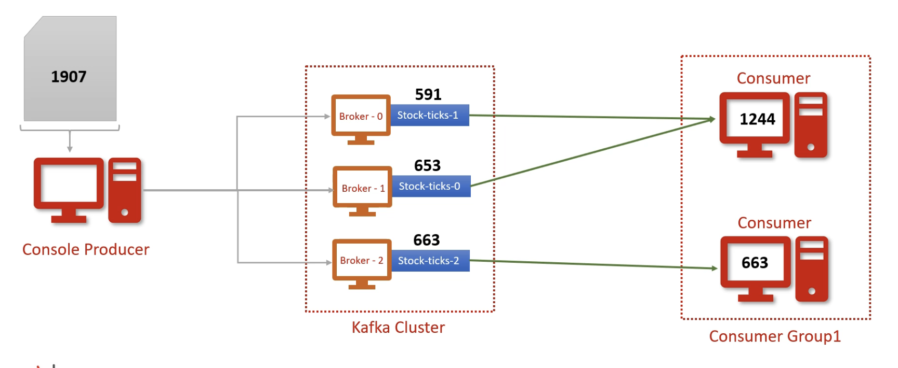

stock-ticks

bin/kafka-console-consumer \

--bootstrap-server localhost:9092 \

--group group1

--topic stock-ticks –from-beginning

bin/kafka-console-producer \

--broker-list localhost:9092 \

--topic stock-ticks < ~/Downloads/data_kafka/sample1.csv

Let me summarize it. So, we created three brokers, and they all have their own personal data directories, right? Then we created a stock-ticks topic with three partitions. And these partitions are stored at three different brokers. Make sense? So we are now seeing the partition one. Let me get in further. Here is the data file. This is these so-called Kafka log file where Kafka would store all the partition data. Let us dump it. I want to see what is there inside this log file. And we have a tool to do that. Kafka dump log and the files to dump. What do you see? Base offset, last offset, and the total records. And then the next packet. Then the next packet and so on. So I have a total of 591 records in this partition. The record counter starts from offset 0 and goes up to 590, right? Let me dump the other partition logs. Partition 0 has got 653 records. And the partition 2 has got 663 records. A log dump is a rich tool. You can even print the whole data set. But my job is done. Now I know which partition has got what? And I can also make a guess that the first consumer got these two partitions and processed one thousand two hundred forty four records. The second consumer has got a single partition and processed 663 records. Make sense? So what we did in this lecture. We learned that the Kafka cluster will store data in the topic partitions. Each partition is managed by a separate broker as a storage directory, and the actual data sets inside the log files. You can use the log dump tool to investigate these log files. The next thing that we learn is this - Consumers can work in consumer group to share the work load and try to achieve workload balance to the extent it is possible. The main objective of this demo was to give you an insight into how partitions and consumer groups are used. Running on a multi node cluster was just a bonus that you got. Great! See you again. Keep learning and keep growing.

Kafka Storage Architecture:

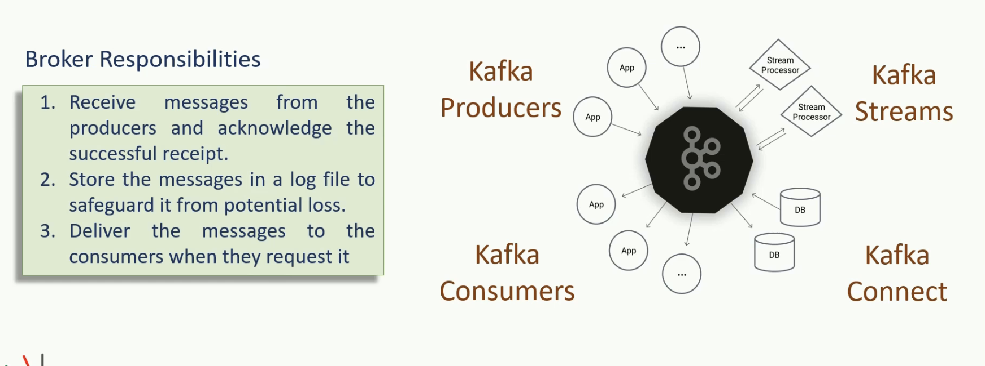

Welcome back. In this section, we start exploring Kafka internals and some architectural concepts. These fundamental concepts are critical for the rest of the course. Great. Let's start. What is a Apache Kafka? Think about it. You must be categorically sure about the answer. Apache Kafka is a messaging broker. That is all, everything else is an API, library or a framework to either interact with the Kafka broker or work with the data in real-time. Kafka broker is a middleman between producers and consumers, and it plays three primary responsibilities. Receive messages from the producers and acknowledge the successful receipt. Store the message in a log file to safeguard it from potential loss. Storage is also critical to ensure that the consumers can consume it later, and they do not necessarily need to read it in real-time. Finally, deliver the messages to the consumers when they request it. That's all at a high level. That is what Kafka broker does. However, that's an oversimplified answer to the question about Kafka. A more elaborated answer could be something like this. Apache Kafka is a horizontally scalable, fault-tolerant, distributed streaming platform, and it is consciously designed for building real-time streaming data architecture. This new definition is a lot to understand. So, I break things into three parts to make it easy to understand. In the first part, I will talk about Kafka message storage architecture. This discussion will help you to understand some core concepts such as Kafka topics, logs, partitions, replication factor, segments, offsets, and offset-index. Then we will move into Kafka cluster architecture. This discussion will help you understand some concepts associated with Cluster formation, Zookeeper, and the Controller. Finally, will tie up these two architectures and try to understand how the work is distributed in the Kafka cluster. In this part, you will learn some concepts such as Leaders, Followers, In Sync Replicas, committed and uncommitted messages. Great! That's all for this video. In the next video, we will learn about Kafka storage architecture. See you in the next lecture. Keep learning and keep growing.

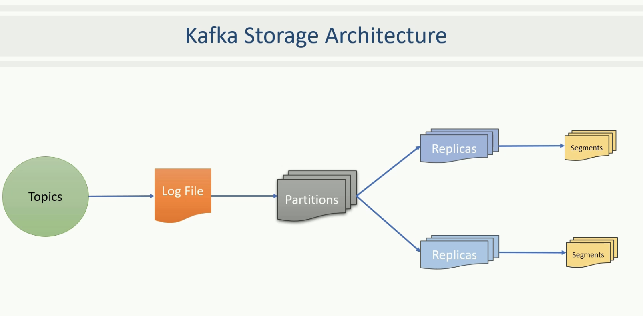

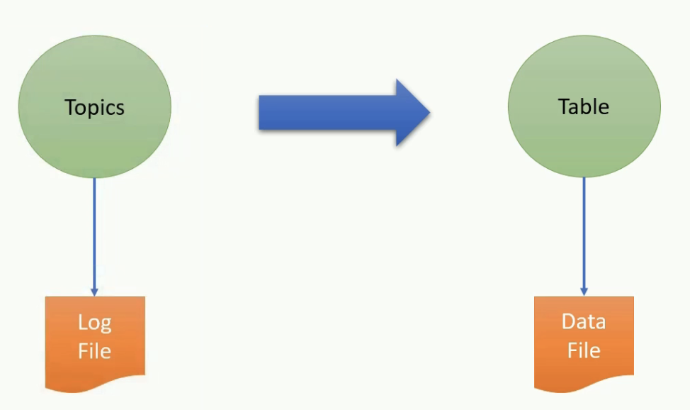

Welcome back. In the earlier lectures you already learned that Apache Kafka organizes the messages in topics, and the broker creates a log file for each topic to store these messages. However, these log files are partitioned, replicated and segmented. In this lecture, I will not only explain but also show you the Kafka log file organization. So, this lecture is going to be a working session. Great! Let's start with a high-level concept of the Topic. What is a Kafka Topic? A topic is a logical name to group your messages. Like in a database, you must create a table to store your data records, in Kafka, you must create a topic to store messages. So let's create a topic and see a few things in action. I have a three node Kafka cluster running on my machine. I've configured things in a way that I can efficiently work from the IntelliJ IDEA, and I do not have to switch screens. I've also set all three brokers to use this temp directory as a home directory. What does that mean? That means, everything that my Kafka brokers are going to create, will reside in this tmp directory. This arrangement makes things easy to watch and understand what is happening under the hood. My three node Kafka Cluster is up, and all three brokers are running. Let me show you what do we have inside the temp directory. I have this zookeeper directory. Kafka needs the zookeeper, and I'll explain it in a different video. However, for now, you can think of this directory as a zookeeper data directory where the zookeeper will store its data. Other three directories are the data directories of my three Kafka brokers. Let me take you inside one of these directories. So these are some initial files. When a broker starts, it creates some initial files. Most of these files would be empty at this point. I haven't created any topic yet, so we do not have any file for a topic. This is an initial state of the Kafka broker. We do not want to get into further details of these files. Our focus is to understand how a topic is organized at the broker level. So, we will create one topic and investigate these directories to know how a topic is physically held at the broker. So let's create a topic. Here is the command that I would use to create a Kafka topic. Kafka topics is a shell script on Linux machine and a batch script on a Windows machine. Rest all our arguments to the command. The first argument is to tell Kafka that we want to create a topic. The second argument is the zookeeper coordinates. The third argument is the name of the topic. These three arguments are mandatory and fundamental arguments for the command to work. When you create a topic in Apache Kafka, you must specify two more configurations. Number of Partitions and Replication Factor. If you do not provide these parameters, Kafka assumes a default value, but every topic must have some values for these two parameters. Let's execute this command, and then I'll talk about the partitions and replication factor. Great! Topic creation is complete. Now, let me talk about the topic partition. What are they? In Kafka, a single topic may store millions of messages, and hence, it is not practical to keep all those messages in a single file. The topic partitions are a mechanism to break the topic further into smaller parts. Right? But what does it mean for Apache Kafka? For Apache Kafka, a partition is nothing but a physical directory. What does it mean? It means a simple thing. Apache Kafka creates a separate directory for each topic partition. I created a topic for invoices and specified five partitions, that means, Kafka will create five directories for the invoice topic. You can see it here. We got five new directories because we created five partitions for the invoice topic. So, Kafka topic partitions are nothing but directories. You create a Topic with 3 partitions, Kafka broker will create three directories. You asked for 10 partitions, the broker will create 10 directories. Simple isn't it? I hope you got some sense about Kafka Topic partitions. Great! See you again. Keep learning and keep going.

Replication Factor:

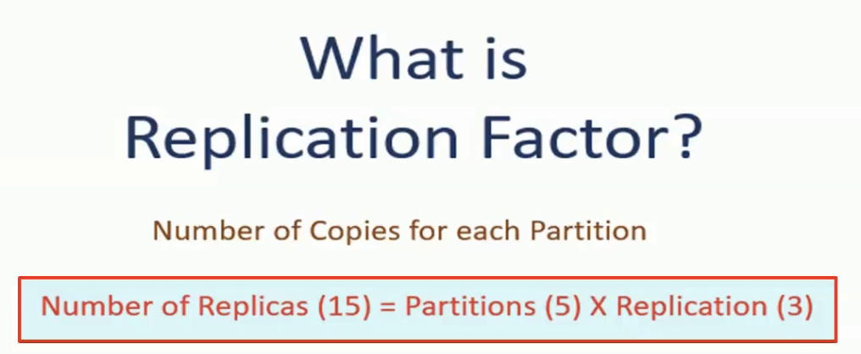

Welcome back. Now the next thing that I want to talk about is the Replication factor. What is the replication factor? The replication factor specifies how many copies do you want to maintain for each partition. That simply means the replication factor multiplies to the number of partitions. For example, we created one Topic for invoices. While creating the Topic, we specified the number of partitions as five and a replication factor as three. In this case, Kafka should create 15 directory. The calculation is simple. We wanted to produce five partitions and maintain three copies of each partition, And that makes 15 directories. But where are they? I showed you only 5 directories. Where are the other 10 directories? They are created on the other brokers. So if you look at the other two broker homes, they also have those five directories. Altogether, we have five partitions on each broker, and in total, we have 15 directories. We term these directories as a partition replica. How do I name them? Well, I can call it as - the First replica of partition 0. Second replica of partition 0, third replica of partition 0. Similarly, we have three replicas of partition 1 and so on. Great! So we understand that the number of partitions and replication factor multiplies and results into directories. And we call them as partition replicas. In our example, we have 15 partition replicas. All these 15 directories are part of the same Topic, but they're distributed among the available brokers. Great! See you again. Keep learning and keep growing.

Classification of Replica:

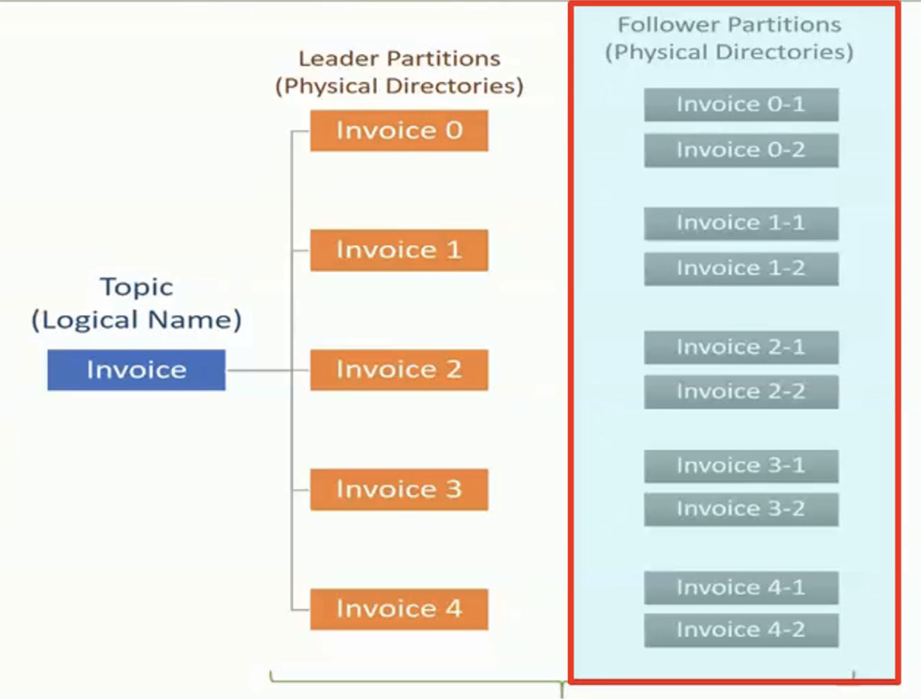

Welcome back. Now I want to talk about the classification of the partition replicas. So, we can classify topic partition replicas into two categories. Leader partitions and Follower partitions. While creating the Topic, we specified the number of partitions as five, and Kafka creates five directories. These five directories are called the Leader Partitions. So, the leaders are created first. Then we also specified the replication factor as three. That means Kafka should ensure three copies for each of these five partitions. One is already there, the leader, hence Kafka creates two more directories for each leader, and we call these copies as Followers. Remember, the follower is a duplicate copy of the Leader. And all of them are nothing but directories. If you want to know, which one is the leader and which ones are followers, you can use Kafka topics command once again to describe the Topic. The output clearly tells, where does the leader reside for the given partition. This number is the broker id that holds the leader partition for partition id 0. We will learn more about leaders and followers in further lectures. However at this stage it is essential to understand that there are the leader partitions that are followed by several followers. The number of follower partition depends on the replication factor. Great! See you again. Keep learning and keep going.

Kafka Log Segment:

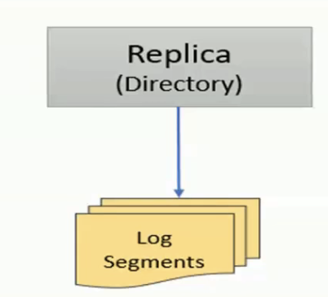 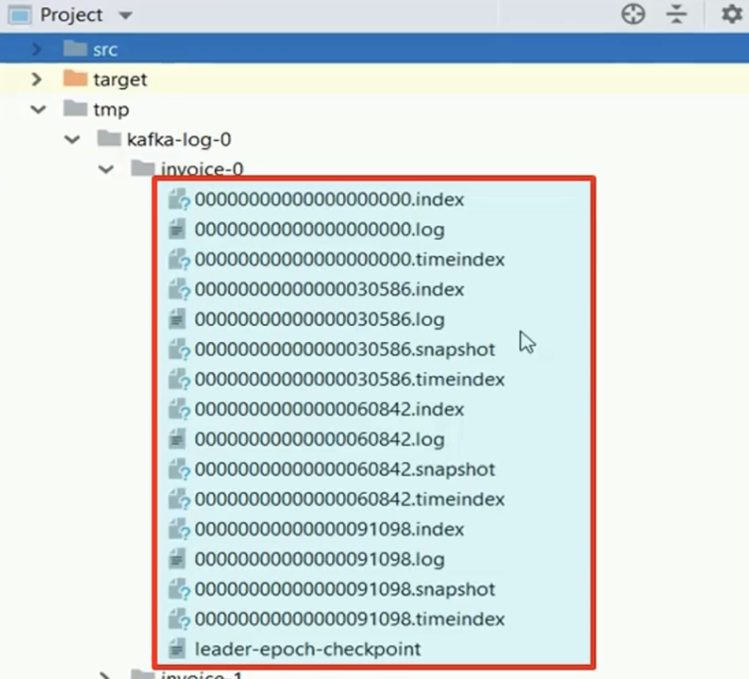

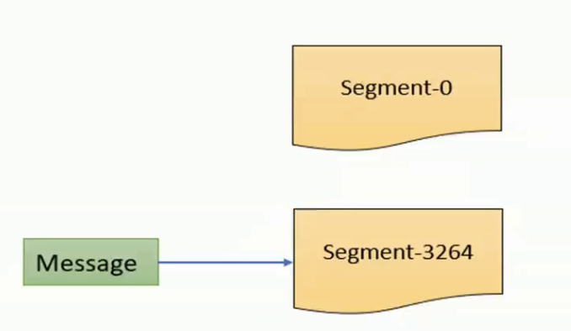

Welcome back. So we are done with the directories. These directories are there to hold log files where messages are stored. So the next thing I want to talk about is the log file. The messages are stored within the directories in the log files. However, instead of creating one large file in the partition directory, Kafka creates several smaller files. That means the Kafka log files is split into smaller files known as segments. Let me show you the first segment file. Here is the first log segment file. Every topic partition would create the first log segment file, and you can see them in each partition. Now you start sending messages and see what happens next. Let me execute my producer program. I'm configuring my producer to send half a million short messages. Average message size is roughly 20 bytes. Let's run it. Finished. Quick, isn't it.? Now you can see a bunch of log segment files. But how it happens? The next important thing to understand is the logic behind the splitting of segment files. Let's try to understand how this split happens. When the partition receives its first message, it stores the message in the first segment. The next message also goes in the same segment and the segment file continues to grow until the maximum segment limit is reached. As the Kafka broker is writing to the partition, If the segment limit is reached, they close the file and start the new segment. That's how we get multiple segment files in each partition directory. The default maximum segment size is either one G.B. of data or a week of data, whichever is smaller. I configured the maximum segment size as one MB, and hence I got multiple segments. Otherwise, this split happens only after one G.B. limit is reached. Great! See you again. Keep learning and keep going.

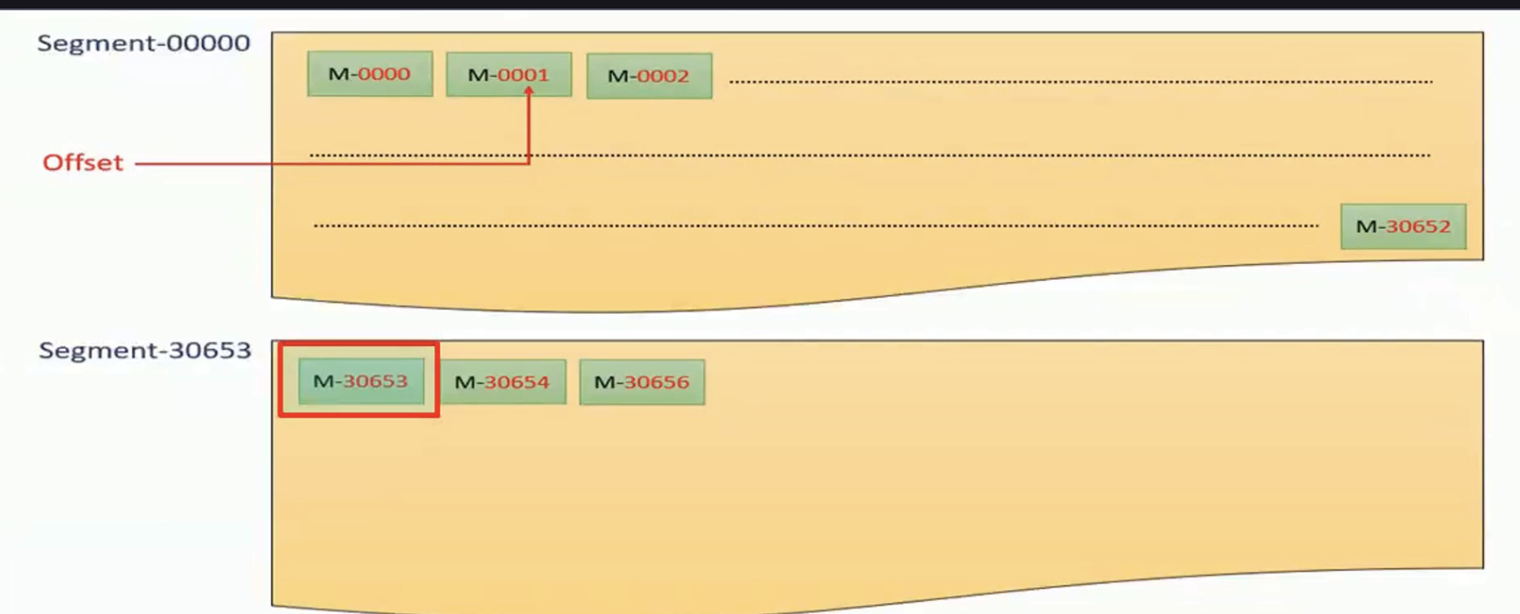

Welcome back. There is one critical thing to understand about the Kafka messages. Each Kafka message in the partition is uniquely identified by a 64 bit integer offset. Every Kafka message within a single partition is uniquely identified by the offset. For example, the offset for the first message in the partition would be 0000, the offset for the second message would be 0001, and so on. This numbering also continues across the segments to keep the offset unique within the partition. Let us consider that the offset of the last message in the first segment is 30652. Assume that the maximum segment limit is reached, so the Kafka should close this segment and create a new segment file for the next message. The offset for the first message in the new segment continues from the earlier segment and hence, the offset of the first message in the second segment would be 30653. For easy identification, the segment file name is also suffixed by the first offset in that segment. And you can see that here. You should remember that the offset is unique within the partition. If you look across the partitions, the offset is starts from zero in each partition. Hence the offset is a 64 bit integer giving a unique ID to the message in a given partition. Since the offsets are not unique across the topic, if you want to locate a specific message, you must know at least three things. Topic name, Partition number and then Offset number. Great! See you again. Keep learning and keep growing.

Locate Topic:

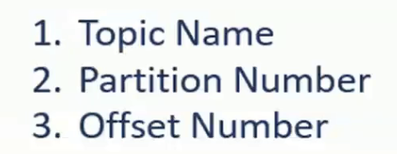

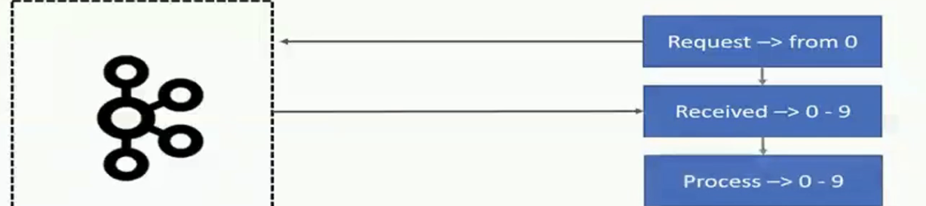

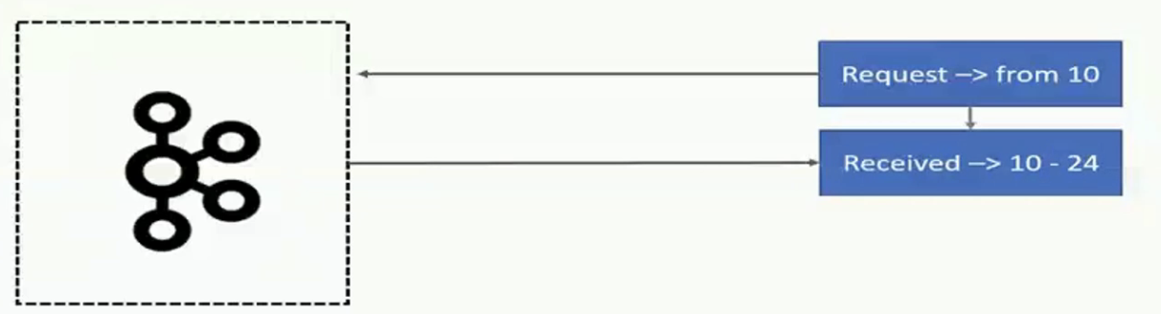

Welcome back. If you want to locate a specific message, you must know at least three things. Topic name, partition number, and then the offset number. At first sight, this arrangement of uniqueness looks strange. Let me explain. If you're thinking database terms, this unique identification does not make a good sense for locating the messages. The topic name is like a table name in the database. But partition and offset are just numbers. In database applications, we may want to access data on some critical columns such as invoice_number, customer_name, or customer_id. However you cannot do that in Kafka because messages are not structured into column names. And that's why this arrangement of uniqueness looks strange. However this numbering may not be a problem for real-time stream processing application. How? Let's take an example to understand it. In a stream processing application, the requirement is different. A stream processing application wants to read all messages in a sequence. Let's assume that you have a stream processing application that computes loyalty points for the customer in real-time. The application should read each invoice and calculate loyalty point. While computing loyalty points, you need customer_id and the amount, but you must read all the events. Let's look at the sequence of activities. The application connects to the broker and asks for the messages is starting from the offset zero. Let's assume the broker sense ten messages to the application. The application takes a few milliseconds to compute loyalty points on those 10 invoices. Now it is again ready to process a few more messages. So, it goes back to the broker and requests for more messages starting from offset 0010. The broker provides another batch of 15 messages. Next time the application requests for another set of messages. This process continues for the life of the application. The process explained in this example is the typical pattern of how a stream processing application would work. In this process, you must have noticed that the consumer application is requesting messages based on the offset. The point is a straightforward. Kafka allows consumers to start fetching messages from a given offset number. This means, if consumer demands for messages beginning at offset hundred, the broker must be able to locate the message for offset hundred. To help brokers rapidly find the message for a given offset, Kafka maintains an index of offsets. The index files are also segmented for easy management, and they are also is stored in the partition directory along with the log file segments. You can see them here. Finally, the last thing in this lecture. The time index. Kafka allows consumers to start fetching messages based on the offset number. However, in many use cases, you might want to seek messages based on timestamp. These requirements are as straightforward as you want to read all the events that are created after a specific timestamp. To support such needs, Kafka also maintains the timestamp for each message builds a time index to quickly seek the first message that arrived after the given timestamp. The time index is like the offset index, and it is also segmented and stored in the partition directory along with the offset index and log final segment. You might see a few other types of files in the partition directory. But those files have nothing to do with the data. Kafka creates those files to keep some control information and clean them from time to time. We do not care much about those files. Great! So it was a quite long session. But we learned some key concepts about the Kafka broker and how the Kafka topics are logically organized. See you in the next lecture. Keep learning and keep growing.

Kafka Cluster

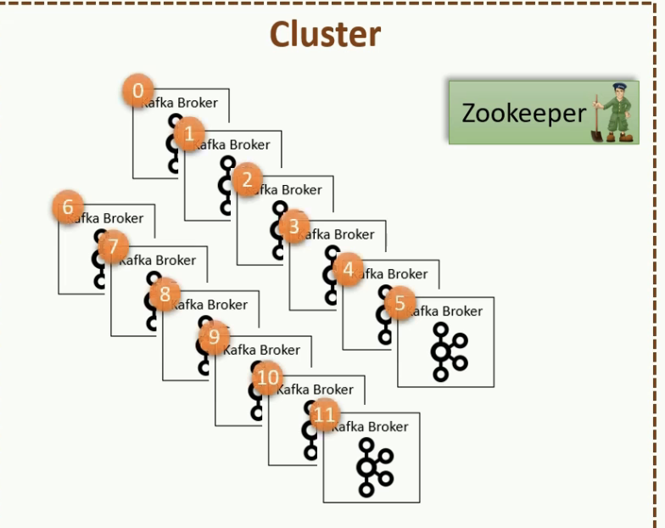

Welcome back. In the previous lecture, we learned about the Kafka broker as an individual entity. The next logical step is to look at the scalability side of Apache Kafka and how Kafka cluster is formed. Let's start. Kafka Brokers are often configured to form a cluster. A cluster is nothing but a group of brokers that work together to share the workload, and that's how Apache Kafka becomes are distributed and scalable system. You're going to start with a single broker in your development environment and deploy a cluster of three or five brokers in your production environment. Later, as the workload grows you can increase the number of brokers in the cluster. It can grow up to hundreds of brokers in a single cluster. However, the notion of clustering brings out two critical questions. Who manages cluster membership? And who performs the routine administrative tasks in the cluster? Let's try to understand the questions and then we will get into the answer. In a typical distributed system, there is a master node that maintains a list of active cluster members. The master always knows the state of the other members. The first question is about the master node. Who manages the list of active brokers, and how does it know that the broker has possibly crashed or a new broker has recently joined the cluster? The second question is also related to the administrative activities that are typically performed by the master in a clustered environment. Let's try to understand this question with an example. Suppose a broker is active and it is taking care of some responsibilities in the cluster. Suddenly the broker leaves the cluster or dies for some reason. Now at this stage, Who will perform those responsibilities? We need someone to reassign that work to an active broker to ensure that the cluster continues to function. I hope you understand the meaning of these two questions. Great. See you again. Keep learning and keep growing.

Zookeeper:

Welcome back. Kafka Broker is a master less cluster. It doesn't follow a master slave architecture. However, it uses Apache ZooKeeper to maintain the list of active brokers. Every Kafka broker has a unique_id that you define in the broker configuration file. We also specify the zookeeper connection details in the broker configuration file. When the broker starts, it connects to the zookeeper and creates an ephemeral node using broker_id to represent an active broker session. The ephemeral node remains intact as long as the broker session with the zookeeper is active. When the broker loses connectivity to the zookeeper for some reason, the zookeeper automatically removes the ephemeral node. So the list of active brokers in the cluster is maintained as the list of ephemeral nodes under the /brokers/ids path in the zookeeper. I can show you that list. You can to start a zookeeper shell using this command. Great. I'm connected to the zoo keeper of my Kafka Cluster. I can easily look at what we have in the zookeeper database. Let me issue the ls command. Great! We have these many hierarchies, but I'm interested in the brokers. So let's check brokers. Okay! So let's look into the ids. Great. So I have 0, 1, and 2. Three brokers in this cluster. What if I bring one broker down. Let me stop broker id 1. Broker id 1 is gone from the zookeeper. Let me start the broker once again. Great. So this is how Kafka maintains the list of brokers in a cluster. The list of active brokers in the cluster is maintained as the list of ephemeral nodes under the /brokers/ids path in the zookeeper. Great. See you again. Keep learning and keep growing.

Connect to zookeeper



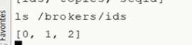

Kafka Controller:

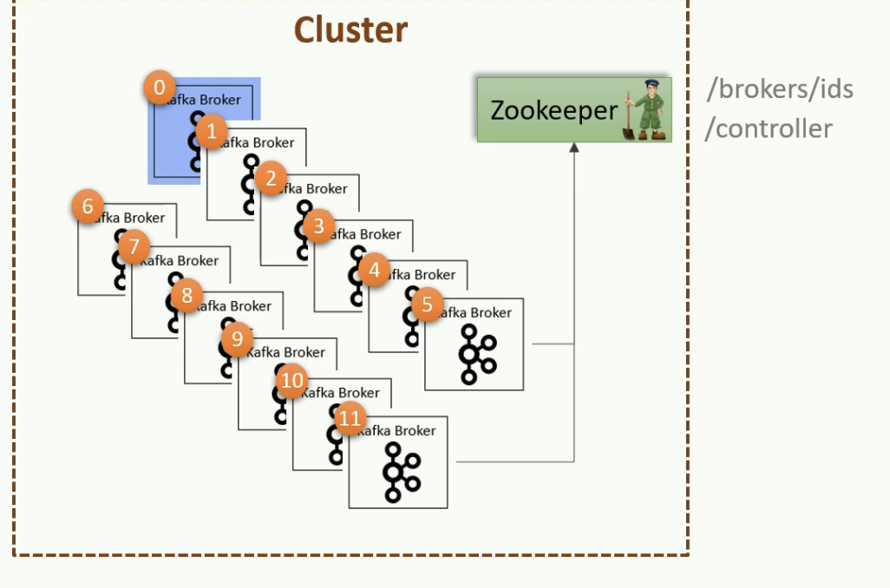

Command to check COntroller

bin/zookeeper-shell localhost:2181 get /controller

Welcome back. Kafka is a master less cluster, and the list of active brokers is maintained in the zookeeper. However, we still need someone to perform the routine administrative activities such as monitoring the list of active brokers and reassigning the work when an active broker leaves the cluster. All those activities are performed by a controller in the Kafka cluster. The controller is not a master. It is simply a broker that is elected as a controller to pick up some extra responsibilities. That means, the controller also acts as a regular broker. So, if you have a single node cluster, it serves as a controller as well as a broker. However, there is only one controller in the Kafka cluster at any point in time. The controller is responsible for monitoring the list of active brokers in the zookeeper. When the controller notices that a broker left the cluster, it knows that it is time to reassign some work to the other brokers. The controller election is is straightforward. The first broker that starts in the cluster becomes the controller by creating an ephemeral (controller) node in the zookeeper. When other brokers start, they also try to create this node, but they receive an exception as 'node already exists,' which means that the controller is already elected. In that case, they start watching the controller more than the zookeeper to disappear. When the controller dies, the ephemeral node disappears. Now, every broker again tries to create the controller node in the zookeeper, but only one succeeds, and others get an exception once again. This process ensures that there is always a controller in that cluster, and there exists only one controller. Let me show you this thing in real. I have a three node cluster. If I ls the root directory of Zookeeper, I can see that there is a controller node already created. So we have a controller elected for this cluster. And that's obvious. But who is the controller? Let's query the controller node. Great. So broken id 0 is the controller. What if I bring that broker down? Let me query it again. Now we have a new controller. Let me bring that poor broker back up. Good. But now, his controller-ship is already gone. So even if the broker comes back, then it doesn't become a controller. Someone else is already elected as a controller. Right? Great! So that's how the Kafka cluster is managed. Just to summarize, zookeeper is the database of the Kafka cluster control information. And one of the broker in the cluster is elected to take up the responsibilities of the controller and take care of the cluster Liberty activities. That's all for this session. See you in the next lecture. Keep learning and keep growing.

Kafka Fault Tolerance:

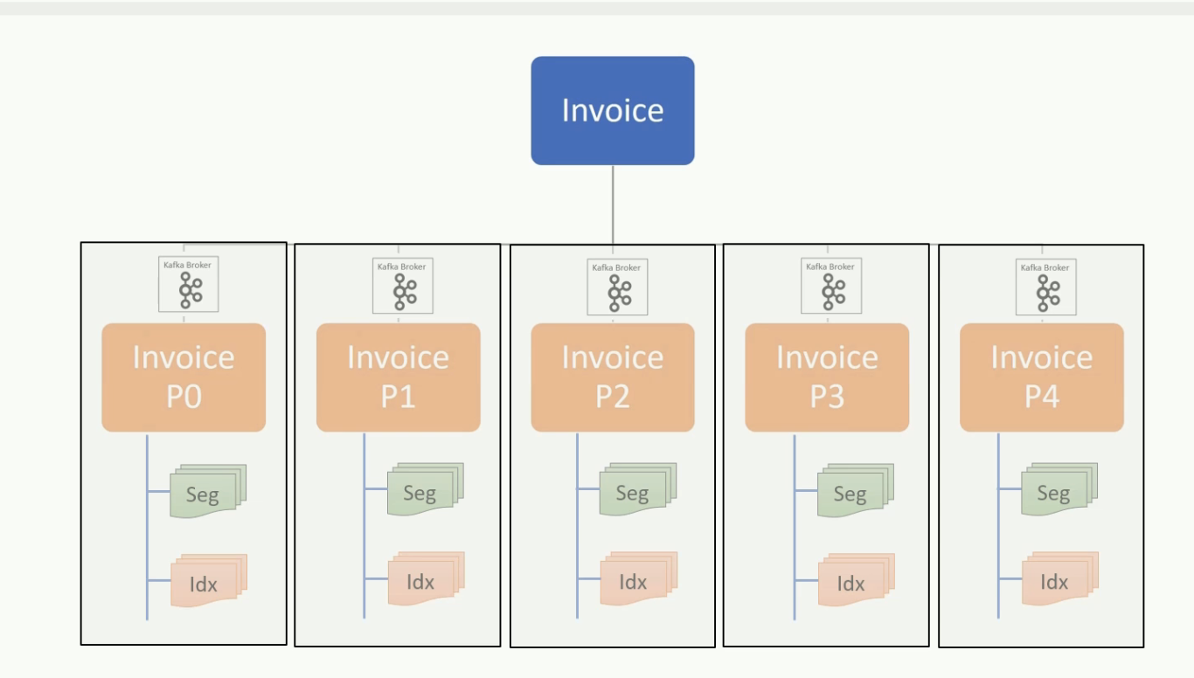

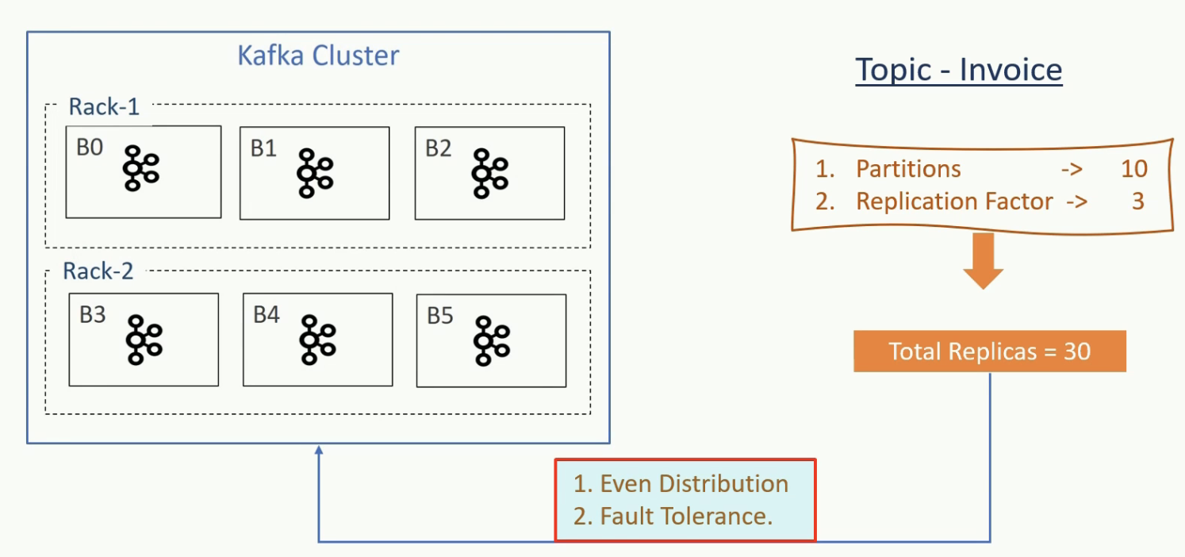

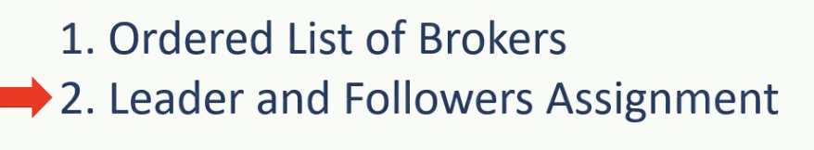

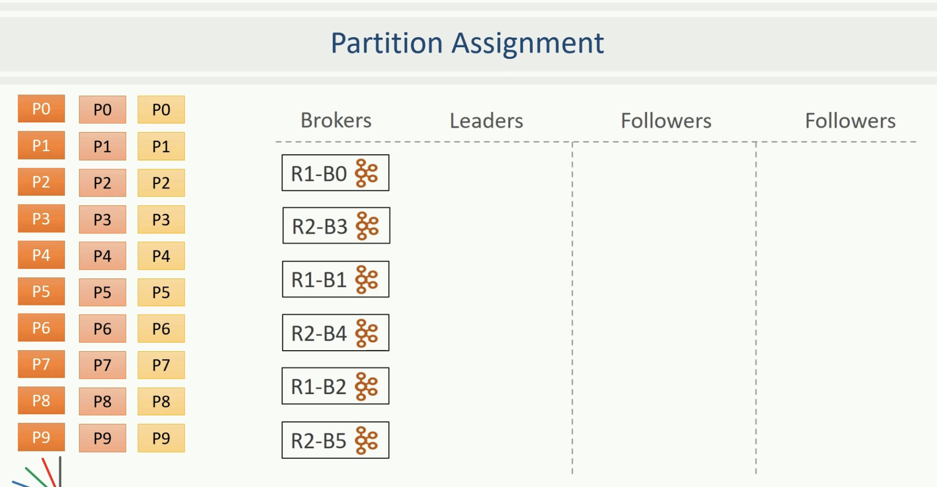

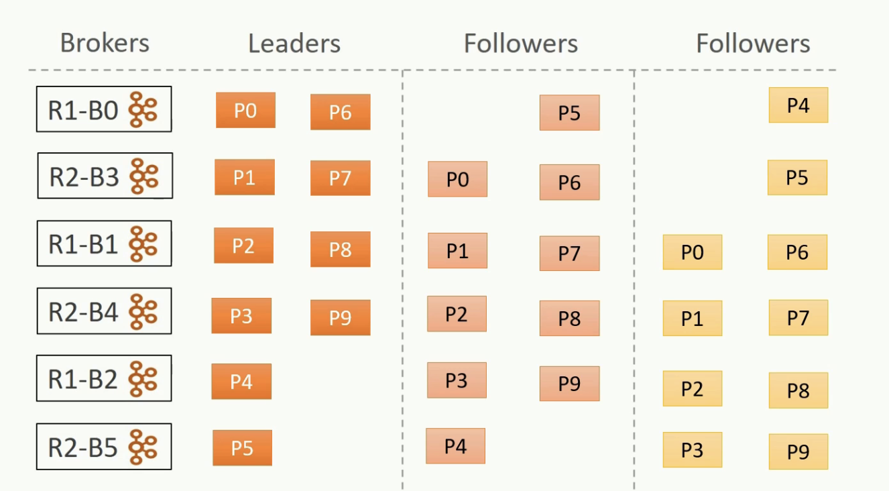

Welcome back. In the earlier session, we explore two different dimensions of Apache Kafka. Log files and Cluster formation. The next logical step is to tie up the relationship between these two dimensions and understand how the work is distributed among the brokers in a Kafka cluster. Primarily, we want to understand what makes Kafka is scalable and far tolerance system. If we look at the kafka topic organization, it is broken in two independent partitions. Each partition is self-contained. What I mean is simple. All the information about the partition, such as segment files and indexes are stored inside the same directory. This structure is excellent because it allows us to distribute the work among Kafka brokers in a cluster efficiently. All we need to do is to spread the responsibility of partitions in the Kafka cluster. The point is is straightforward. When you create a topic, the responsibility to create, store, and manage partitions is distributed among the available brokers in the cluster. That means every Kafka broker in the cluster is responsible for managing one or more partitions that are assigned to that broker. And that is how the verdict is shared by the brokers. Having said that, let's try to understand it with the help of an example. Kafka cluster is a group of brokers. These brokers may be running on individual machines. In a large production cluster, you might have organized those machines in multiple racks. This diagram shows a six-node cluster that is designed using two tracks. Now I have a simple question. How are the partitions allocated to brokers? I mean, how we decide which brokers should be maintaining which partition? Are there any rules for assigning work among the brokers? Let me explain this. Suppose you have six brokers and you placed them into two different racks as shown in the figure. You decide to create a topic with 10 partitions and a replication factor of three. That means, Kafka now have 30 replicas to allocate to six brokers. Are there any rules for the assignment? Well, Kafka tries to achieve two goals for this partition allocation. Partitions are distributed evenly as much as possible to achieve work load balance follower partitions I mean duplicate copies must be placed on different machines to achieve for tolerance. That's it. Just two goals. These are not rules, but you can pick them as a goal that Kafka would want to achieve. Now let's see how it gets distributed. The rule part of it. Right? To distribute our 30 partitions, Kafka applies the following is steps. Make an ordered list of available brokers, and then assign leaders and followers to the list in order. Let's apply the first rule. Kafka begins with a randomly chosen broker in a rack and places it into a list. Let's assume we start with broker 0. Now we have one item on the list. The next broker in the list must be from a different rack. So, let's assume Kafka picks Broker 3. Now we have two brokers in the ordered list. The next one again comes from the first track. Let's say, this time it is broker 1. This goes on as an alternating process for selecting another broker in a different rack. So, we take broker 4, then broker 2, and finally broker 5. That's all. You have an ordered list of brokers. Now we come to the second step. Assigning partitions to this list. We have 30 partitions to allocate to these six brokers. Ideally, Kafka should place five partitions on each broker to achieve the first goal of evenly distributing the partitions. However, we have one other goal to achieve fault tolerance right. What is for tolerance? It is as simple as making sure that if one broker fails for some reason, we still have a copy on some other broker. Further, making sure that if the entire rack fails, we still have a copy on a different rack. We can achieve fault tolerance by merely placing duplicate copies on different machines. For example, the first partition has three copies. All we need to do is to make sure that these three copies are not allocated to the same broker in the above list. How Kafka does that? Let us see this step by step process. Once we have the ordered list of available brokers, assigning partitions is as simple as assign one to each broker using a round robin method. Kafka starts with the leader partitions and finishes creating all leaders first. So we take the leader of the partitions zero and assign it to broker 0. The leader of partition one goes to broker 3, the leader of partition 2 learns on broker 1 and so on. Once the leader partitions are created, it starts creating the first follower. The first follower allocation simply starts from the second broker in the list and follows a round robin approach. So, we skip the first broker in the list and place the first follower of partition 0 to broker 3, the first follower of partition 1 goes to broker 1. Similarly, the first follower of partition 2 goes to broker 4, and so on others are also created. Finally, it begins with the list of the second follower and maps them to the same broker list by jumping one more broker from the previous start. So the second follower of partition zero goes to broker one, and similarly, others are also created. Great! We are done. This is what happens when you created topic. Leaders and followers of the topic are created across the cluster. If you look at the outcome of this allocation, we couldn't achieve a perfectly even distribution. The broker 0 has got four and broker 4 has got six partitions. However, we made an ideal fault tolerance at the price of little disparity. Let's quickly check the fault tolerance level. The leader of the fourth partition is placed at the broker 2 that sits in the first track. However, the first follower of partition 4 goes to a different track a broker. 5. So even if one of the racks is entirely down, we still have at least one copy of the partition 4 available on the other. Similarly the second follower is placed at a different broker B0. So even if 2 brokers are down, we will still have at least one broker available to serve the partition 4. You can validated with other partitions as well. They all are well arranged in a way that at least two copies are placed on two different tracks. This arrangement is ideal for fault tolerance. Great. So we learn how the replicas are distributed among the brokers in the cluster, making the system fault tolerant. However, distributing the replicas among the brokers is the first half of the work distribution. The second half of the problem is to define the responsibility of an individual broker. The session is getting too long. So, let's close it here, and we'll resume the discussion in the next lecture. See you in the next lecture. Keep learning and keep growing.

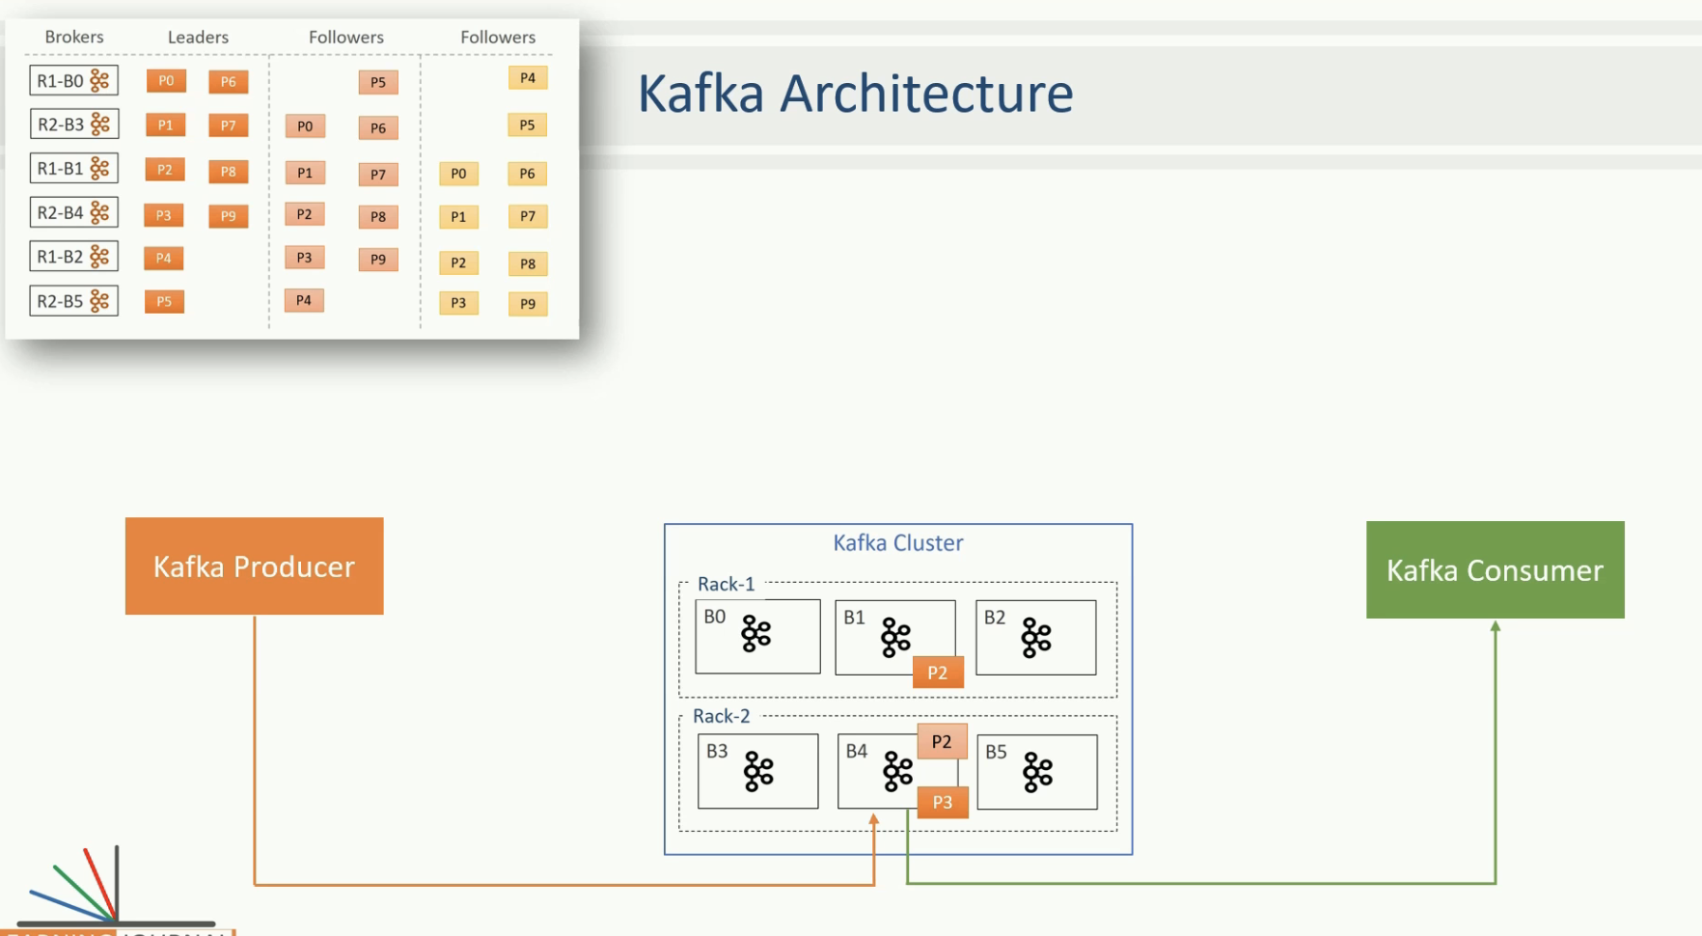

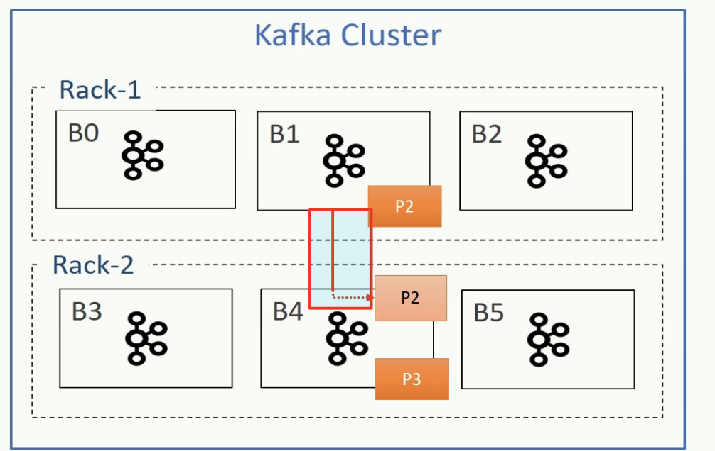

Welcome back. In the previous session, we learn how the replicas are distributed among the brokers in the cluster. In this lecture, I'll talk about the responsibilities of the leader and the followers. So, let's start. We learned that the broker manages two types of partitions. Leader partition and Follower partition. Depending upon the partition type, a typical broker performs two kinds of activities. Leader activities and follower activities. Let us try to understand it. In the example, we allocated 30 replicas amongst six brokers. Now each broker owns multiple replicas. For example, the broker 4 holds six replicas. Two of these replicas of the leader partitions, and the remaining four are the following partition. So, the broker acts as a leader for the two leader partitions, and it also acts as a follower for the remaining four follower partitions. What does that mean? Let's try to understand, what does it mean by a broker to act as a leader. Regarding Kafka broker, being a leader means one thing. The leader is responsible for all the requests from the producers and consumers. For example, let's assume that a producer wants to send some messages to a Kafka topic. So the producer will connect to one of the brokers in the cluster and query for the topic metadata. All Kafka brokers can answer the metadata request, and hence the producer can connect to any of the broker and query for that metadata. The metadata contains a list of all the leader partitions and their respective host and port information. Now the producer has a list of all leaders. It is the producer that decides on which partition does it want to send the data, and accordingly send the message to the respective broker. That means the producer directly transmits the message to a leader. On receiving the message, the leader broker persists the message in the leader partition and sends back an acknowledgement. Similarly, when a consumer wants to read message. It always reads from the leader of the partition. We learn more detail about the producer and consumer interaction in the next section. However, at this stage, you should be clear that the producer and the consumer always interact with the leader. And that's what is the responsibility of the leader broker. Interact with the producer and the consumer. Now let's come back to the follower. Kafka broker also acts as a follower for the follower partitions that are allocated to the broker. In the figure, the broker B4 owns four follower partitions and hence the B4 acts as a follower for these replicas. Followers do not serve producer and consumer requests. Their only job is to copy messages from the leader and stay up to date with all the messages. The aim of the follower is to get elected as a leader when the current leader fails or dies. So, they have a single point agenda. Stay in sync with the leader. Why? Because they can't get elected as a leader if they are falling behind the leader and fail to be in sync with the leader by copying all the messages. The next question is this - How does the follower stay in sync with the leader? To stay in sync with the leader, the follower connects to the leader and requests for the data. The leader send some messages, and the followed persists them in the replica and requests for more. This goes on forever as an infinite loop to ensure that the followers are in sync with the leader. Great. See you again. Keep learning and keep growing.

What is ISR:

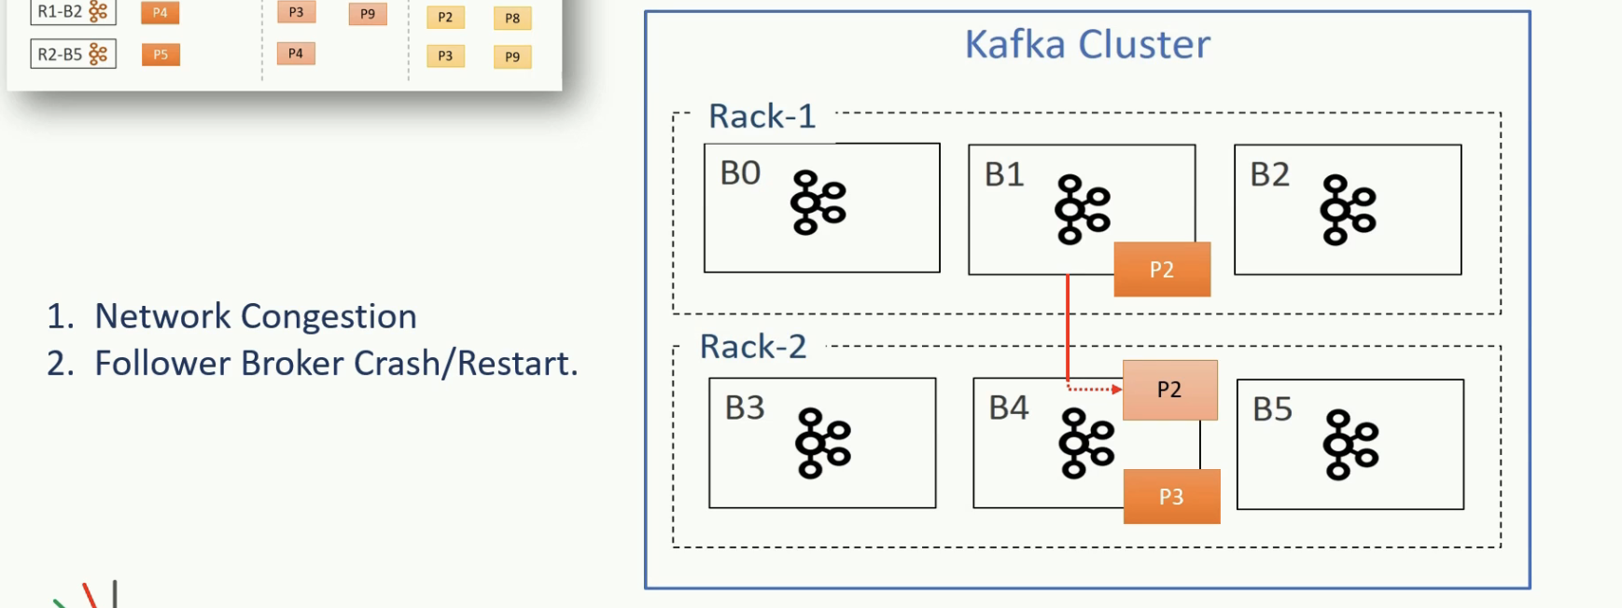

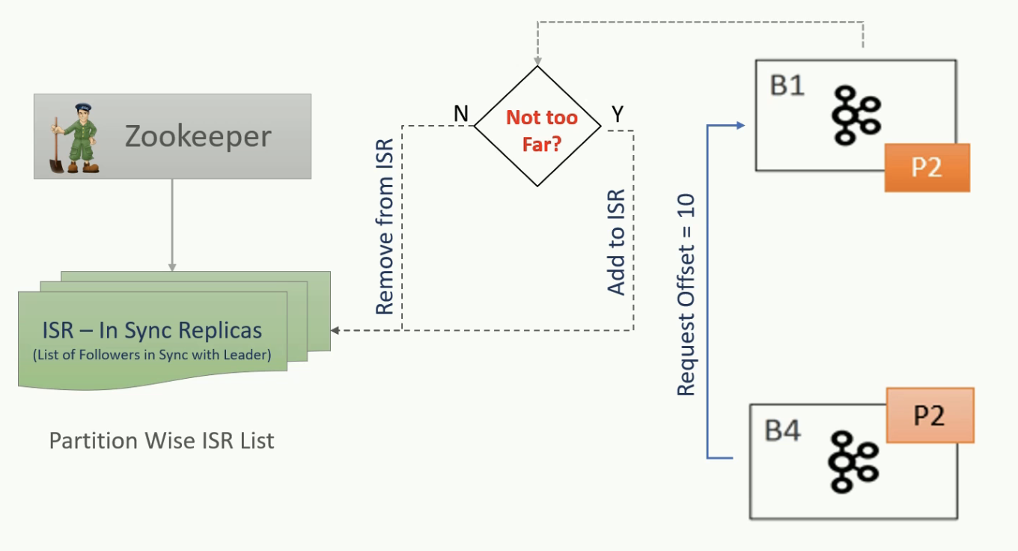

Welcome back. We already learn that the followers would continuously copy the messages from the leader and stay in sync with the leader. In this lecture, we will learn about the ISR list. The method of copying messages that the follower appears full proof. However, some followers can still fail to stay in sync for various reasons. Two common reasons of network congestion and broker failures. Network congestion can slow down replication, and the followers may start falling behind. Right? When a follower broker crashes, all replicas on that broker will begin falling behind until we restart the follower broker and they can start replicating again, right? Since the replicas may be falling behind, the leader has one more important job to maintain a list of In-Sync-Replicas(ISR). This list is known as the ISR the list of the partition and persisted in the zookeeper. And this list is maintained by the leader broker. The ISR list is very critical. Why? Because all the followers in that list are known to be in sync with the leader, and they are an excellent candidate to be elected as a new leader when something wrong happens to the current leader. And that makes the ISR list a critical thing. However, there is one more question that follows. You might wonder, how do a leader would know if the follower is in sync or still lagging? Let's try to understand that. The follower will connect to the leader and request for the messages. The first request would ask the leader to send messages is starting from the offset zero. Assume that the leader has got ten messages, so it sends all of them to the follower. The follower restores them and do the replica and again requests for new messages starting from offset 10. In this case, since the follower asked for offset 10, that means a leader can safely assume that the follower has already persisted all the earlier messages. So by looking at the last offsets requested by the follower, the leader can tell how far behind is the replica. Now the ISR list is easy to maintain. If the replica is 'not too far,' the leader will add the follower to the ISR list, or else the followed is removed from the ISR list. That means the ISR list is dynamic and the followers keep getting added and removed from the ISR list depending on how far they maintain their in0sync status. However, there is a catch here. How do we define the 'not too far?' As a matter of fact the following will always be a little behind and the leader, and that's obvious because follower needs to ask for the message from the leader, received the message over the network, store them into the replica and then ask for more. All these activities take some time. And hence, the leader gives them some minimum time as a margin to accomplish this. That is where the notion of 'not too far' arrives. The default value of 'not too far' is 10 seconds. However, you can increase or decrease it using Kafka configurations. So the replica is kept in the ISR list if they are not more than 10 seconds behind the leader. That means, if the replica has requested the most recent message in the last 10 seconds, they deserve to be in the ISR. If not, the leader removes the replica from the ISR list. Great. See you again. Keep learning and keep growing.

Commited vs un-commited Message:

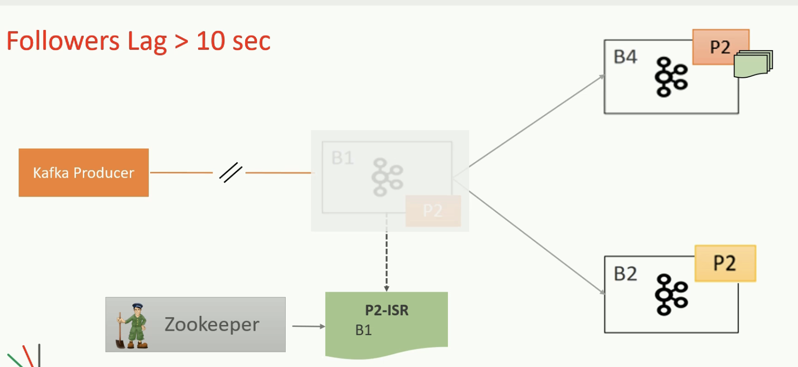

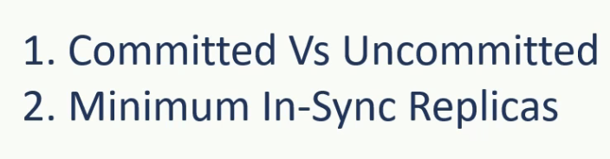

Welcome back. In this lecture, we will learn about the committed vs. uncommitted messages. The mechanism to maintain the ISR list is quite fancy. However, we still have a gotcha in this mechanism. The maintenance of the ISR list leads to some new concepts. Let us try to understand it. We already understand that the followers may be lagging behind the leader for several reasons and they might get removed from the ISR. Right? Assume all the followers in the ISR are 11 seconds behind the leader. That means none of them qualified to be in the ISR. So, your ISR list becomes logically empty. The messages are only at the leader, right? Now for some reason, the leader crashed, and we need to elect a new leader. Who do we choose? If we elect a new leader among the followers that are not in the ISR, don't we lose those messages that are collected at the leader during the most recent 11 seconds? Yes, we miss them, but how do we handle that? We don't want to lose anything. The solution is simple which is implemented using two concepts. The first idea is to introduce the notion of committed and uncommitted messages. The second idea is to certain minimum in sync replicas configuration. Let us try to understand these two things. You can configure the leader to not to consider a message committed until the message is copied at all the followers in the ISR list. If you do that, the leader may have some committed as well as some uncommitted messages right? The message is committed when it is safely copied at all replicas in the ISR. Now, if the message is committed, we cannot lose it until we lose all the replicas. Right? So committed messages are now taken care of. We cannot lose them. However, if we lose the leader, we still miss the uncommitted messages. Isn't it? But the uncommitted messages shouldn't be a worry, because those can be read sent by the producer. Why? Because producers can choose to receive acknowledgement of sent messages only after the message is fully committed. In that case, the producer waits for the acknowledgement for a timeout period and the reason the messages in the absence of commit acknowledgement. So, the uncommitted messages are lost at the failing leader, but the newly elected leader will receive those messages again from the producer. That's how all the messages can be protected from loss. If you are not too clear about the idea, no worries. We'll be covering it again in this cause when we start creating examples. Great. See you again. Keep learning and keep growing.

Minimum Insync Replicas:

Welcome back. In the earlier lecture we already learned about the committed and uncommitted messages and their relation to the ISR list. In this lecture, we will extend the idea further and learn about the minimum in sync replicas. The data is considered committed when it is written to all the in-sync replicas. Right? That's what I explained. Now let's assume that we start with three replicas and all of them are healthy enough to be in the ISR. However, after some time, two of them failed, and as a result of that, the leader will remove them from the ISR. In this case, even though we configured the topic to have three replicas, we are left with the single in-sync replica that is the leader itself. Now the data is considered committed when it is written to all in-sync replicas, even when all means just one replica(the leader itself), right? It is a risky scenario for data consistency because data could be lost if we lose the leader. Kafka protects this scenario by setting the minimum number of in-sync replicas for a topic. If you would like to be sure that committed data is written to at least two replicas, you need to set the minimum number of in-sync replicas as two. However, there is a side effect of this setting. If a topic has three replicas and you set minimum in-sync replicas to two, then you can only write to a partition in the topic if at least two out of the three replicas are in-sync. When at least two replicas are not in sync, the broker will not accept any messages and respond with 'not enough replicas' exception. In other words, the leader becomes a read only partition. You can read, but you cannot write until you bring another replica online and wait for it to catch up and get in sync. Great. We covered a lot of things in this and earlier session. This all might appear overwhelming. Yes, it is. But nothing to worry. You will learn these things again and again in this course while we start creating applications and examples. That's all I wanted to cover in this session. See you in the next lecture. Keep learning and keep growing.

Kafka Producer API:

Let me quickly summarize. Sending messages to Kafka using producer API is a four-step process.In the first step you will set some configurations that will control the behavior of your producer API. The second step is to create a producer object. The third step is to send all the messages. Finally,if you have no further messages to send,close the producer.The final completed project file is also included in your course material. But I recommend that you pick up the starter project,and try creating the completed example yourself. If you have some doubts,you can refer to the completed project files that I have included in your course material. Great! Do you want to execute this example? Let's do it. Start your zookeeper Then start all three Kafka brokers. Wait for the brokers to start.Finally,create the topic. All these scripts are already included in your starter project. Great! You are now ready to execute the example.Start sending a message and finished sending the message. It took a few seconds to send a million small messages. Great! Isn't it? That's all for this video. In the next video,we will learn some internal of Kafka producer.See you in the next lecture. Keep learning and keep growing.

Produce Message:

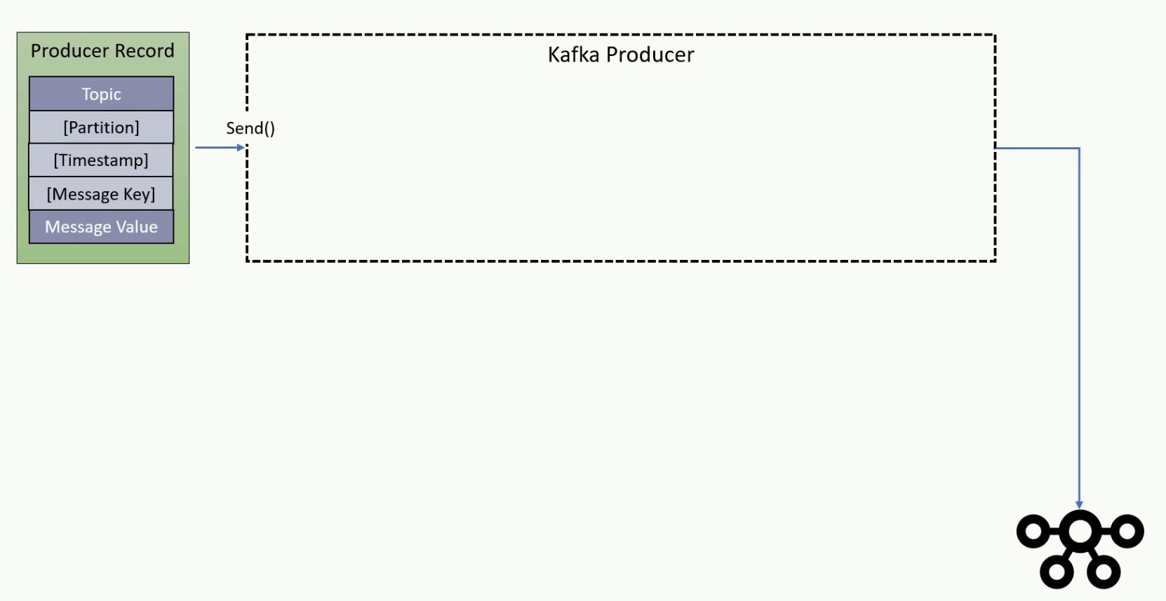

Welcome back. In the earlier lecture,we have learned some basics of Kafka producer. Now it is time to deep dive into the producer APIs. Kafka producer APIs are straightforward. You can create a producer by setting some essential configurations and start sending messages using the send() method. There is only one restriction that you must package your message in a ProducerRecord object.While the send() method is a straightforward, A lot of things happen behind the scenes. Let's try to understand it in detail. We package the message content in the ProducerRecord object with at least two mandatory arguments. Kafka topic name, and message value. Kafka topic name is the destination address of the message. The message value is the main content of the message. Right? Other than these two mandatory arguments, You can also specify the following optional items.Message key,target partition,message timestamp.The message key is one of the most critical argument,and it is used for many purposes,such as partitioning grouping, and joins. You will learn more about the usage of a key as you progress with the course. However,at this stage,consider it as another mandatory argument even if the API doesn't mandate it. Target partition and the timestamp are purely optional, and you may want to set these arguments rarely. I'll talk about these arguments in a minute. The ProducerRecord wraps your message content with all necessary information such as topic name, Key, and timestamp.Once created, you can hand over the ProducerRecord to the KafkaProducer using the send() method. Great. See you again. Keep learning and keep going.

Serialize:

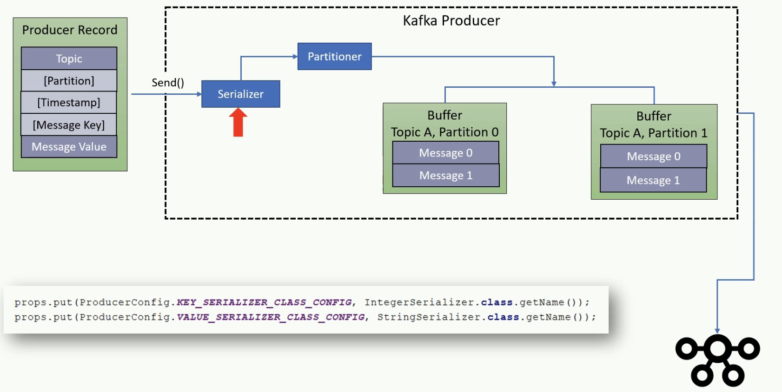

Welcome back. In this video we will learn about the Kafka producer serializer. The Kafka producer is supposed to transmit the ProducerRecord to the Kafka Broker over the network. However, it does not immediately transfer the records. Every record goes through serialization, partitioning, and then it is kept in the buffer.The serialization is necessary to send the data over the network. Without serializing data, you can't transmit it to a remote location. However, Kafka does not know how to serialize your Key and value. That is why specifying a key serializer, and a value serializer serializer class is mandatory that we supply as part of the producer configuration. In the earlier example,we have used we have used IntegerSerializer for the Key and a StringSerializer for the value. However, these serializers are the most elementary serializers, and they do not cover most of the use cases. In a real life scenario, Your events are represented by complex Java objects. These objects must be serialized before the producer can transmit them to the Broker. The StringSerializer may not be a good help for those requirements. Kafka gives you an option to use a generic serialization library like Avro or Thrift. Alternatively, you have a choice to create custom serializer. In the upcoming lectures, I'll create a JSON serializer and show the processes of creating and using a custom serializers. Great. See you again. Keep learning and keep growing.

Partitioner:

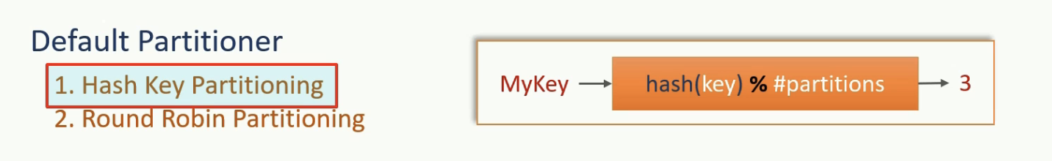

Welcome back. We already learned about the producer serialization. The next thing is the partitioner. Well,every ProducerRecord includes a mandatory topic name as the destination address of the data. However, the Kafka topics are partitioned, and hence, the producer should also decide on which partition the message should be sent. There are two approaches to specify the target partition number for the message.Set partition number argument in the ProducerRecord. Supply a partitioner class to determine the partition number at runtime. As you can see in the Figure, you can optionally specify the partition number in the ProducerRecord. However,that approach is again rarely used. Instead, we supply a Partitioner class that implements your desired partitioning strategy and assigns a partition number to each message at runtime. You can specify a custom partitioner using the properties object. However, even creating a custom partitioner is often not needed. Why? Because KafkaProducer comes with a default partitioner which is the most commonly used partitioner. The default partitioner takes one of the two approaches to determine the destination topic partition. Hash Key Partitioning or Round Robin Partitioning. The first approach is based on them message key. When the message key exists, the default partitioner will use the hashing algorithm on the key to determining the partition number for the message. It is as simple as hashing the key to convert it into a numeric value. Then use the hash number to deduce the target partition. The hashing ensures that all the messages with the same key go to the same partition. However, this algorithm also takes the total number of partitions as one of the inputs. So, if you increase the number of patients in the topic, the default partitioner starts giving a different output. That means, if the partition is based on the key, then you should create a topic with enough partitions and never increase it at the later stage. You can easily over provision the number of partitions in the topic. I mean, if you need hundred partitions, you can easily overprovision it by 25 percent and create 125 partitions. There is not much harm in taking this approach. But remember, if you do increase the number of partitions later, you may have to redistribute the existing messages.Right? When the message key is null, the default partitioner will use a round robin method to achieve an equal distribution among the available partitions. That means the first message goes to the one partition, the second one goes to another partition and the partitioner repeats it in a loop. The default partitioner is the most commonly used partitioner in most of the use cases. However, Kafka allows you to implement your partitioning strategy by implementing a custom partitioner class.But you may not even need a custom partitioner in most of the cases. Great. See you again. Keep learning and keep growing.

Message Timestamp:

Welcome back. We already learned about the producer partition. The next thing is the timestamp. The ProducerRecord takes an optional timestamp field. The message timestamp is optional. However, for a real-time streaming application, the timestamp is the most critical value. For that reason, Every message in Kafka is automatically time stamped. Even if you do not explicitly specify it. Kafka allows you to implement one of the two types of message time a stamping mechanism. Create time and Log Append Time. The CreateTime is the time when the message was produced. The LogAppendTime is the time when the message was received at the Kafka broker. However, you cannot use both. Your application must decide between these two timestamping methods while creating the topic. Setting up a default time a stamping method for a topic is straightforward. You can set the message.timestamp.type topic configuration to 0 for using CreateTime, or you can set it to 1 for using LogAppendTime. The default value is zero. (CreateTime). The producer API automatically sets the current producer time to the ProducerRecord#timestamp field. However, you can override the auto time stamping by explicitly specifying this argument. So, the message is transmitted with the producer time, either automatically set by the producer, or explicitly set by the developer. When using LogAppendTime configuration, the broker will override the producer timestamp with its current local time before appending the message to the log. In this case, the producer time is overwritten by the broker time. However, the message will always have a timestamp, either a producer time or the broker time. I prefer using default configuration as CreateTime whenever I'm using, Producer API to bring data to Kafka because the producer API automatically assigns a timestamp. However, when I'm using some other tool to bring data into Kafka, I need to understand how the tool handles the time stamping. A safer method is to configure the topic for LogAppend Time. So even if your tool is not setting a time, at least the Broker will set some value. Great. See you again. Keep learning and keep growing.

Buffers:

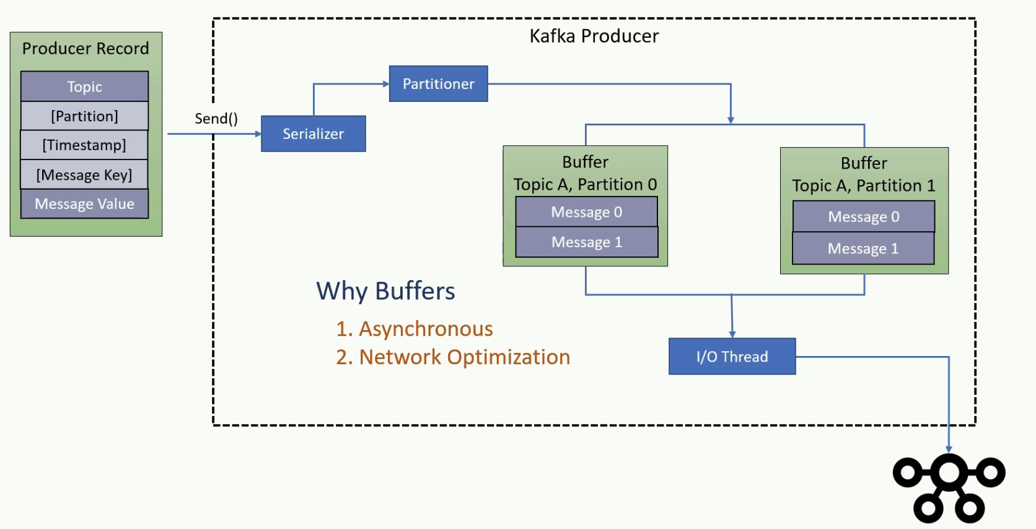

Welcome back. So we understand the key, serialization, and partitioning. However, still a lot is going inside the producer. Let's see what happens next. Once serialized and assigned a target partition number, the message goes to sit in the buffer waiting to be transmitted. The producer object consists of a partition-wise buffer space that holds the records that haven't yet been sent to the server. The Producer also runs a background I/O thread that is responsible for turning these records into requests and transferring them to the cluster. Why do we have this buffering? The buffering of the message is designed to offer two advantages. Asynchronous send API, and Network Roundtrip Optimization. Buffering arrangement makes the send method asynchronous. What does it mean? That means the sender method will add the messages to the buffer and return without blocking. Those records are then transmitted by the background thread. This arrangement is quite convincing as your send() method is not delayed for the network operation. Buffering also allows the background I/O thread to combine multiple messages from the same buffer and transmit them together as a single packet to achieve better throughput. But there is a critical consideration here. If the records are posted faster than they can be transmitted to the server, then this buffer space will be exhausted, And your next send method will block for few milliseconds until the buffer is freed by the I/O Isn't it? Correct? If the I/O thread takes too long to release the buffer, then your send method throws a TimeoutException. When you are seeing such timeout exceptions, you may want to increase the producer memory. The default producer memory size is 32MB. You can expand the total memory allocated for the buffer by setting, buffer.memory Producer configuration. Great. See you again. Keep learning and keep going.

Retries:

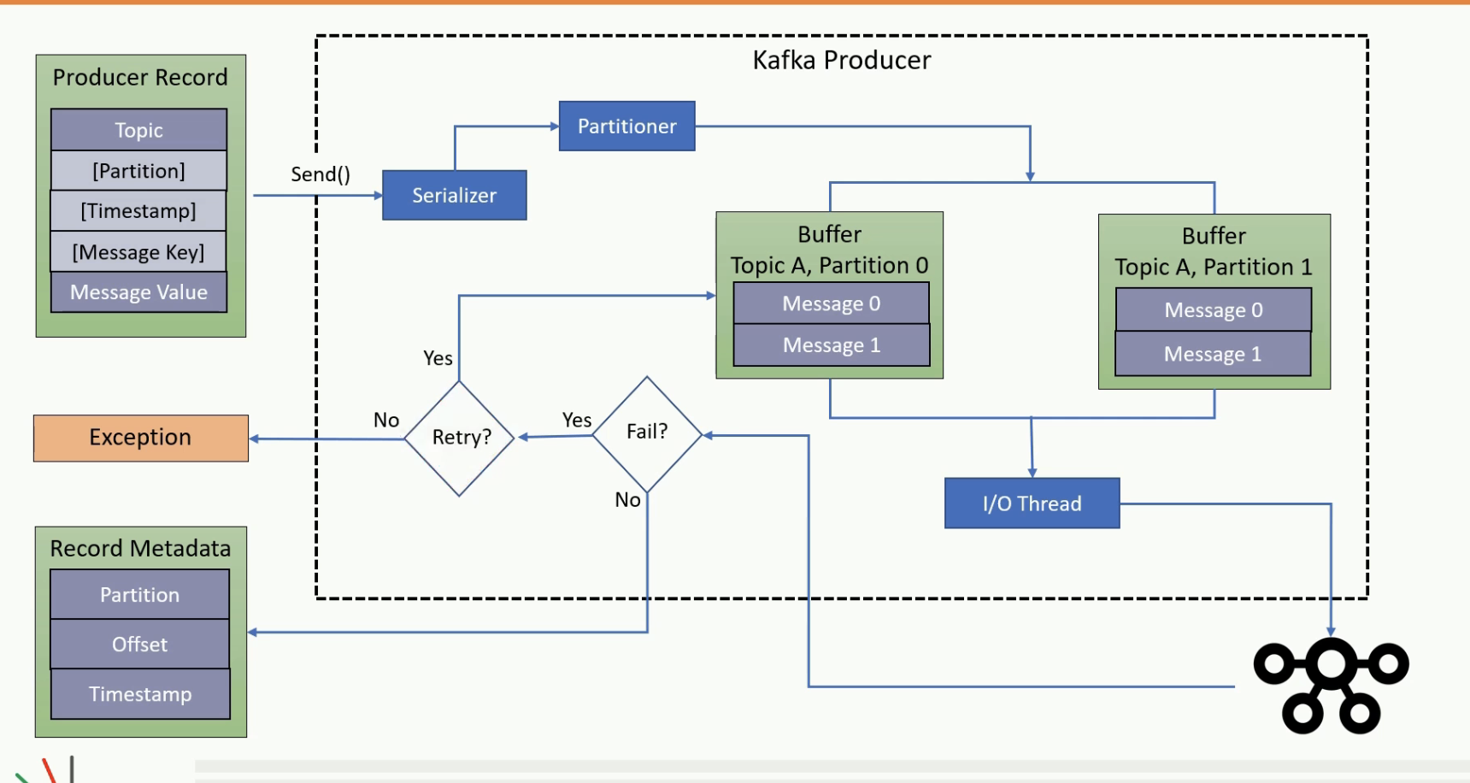

Welcome back. In this video I will talk about the producer retries which is performed by the background I/O thread. The producer background I/O thread is responsible for transmitting the serialized messages that, are waiting in the topic partition buffer. When the broker receives the message, it sends back an acknowledgment. If the message is successfully written to Kafka, the broker will return a success acknowledgement. If the broker failed to write the message, it would return an error. When the background I/O thread receives an error or does not receive an acknowledgment, it may retry sending the message a few more times before giving up and throwing back an error. You can control the number of read drives by setting the retries producer configuration. When all the retries are failed, the I/O thread will return the error to the send() method. Great. See you again keep learning and keep going.

Summary:

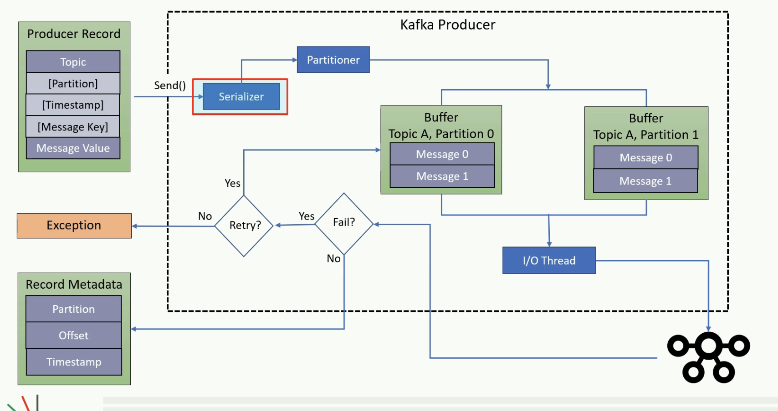

Welcome back. So we learned about the internal workings of the producer API. Before we start creating some more producers, let me summarize the producer internals. We use the producer.send() method to handover the ProducerRecord to the KafkaProducer object. The KafkaProducer object will internally serialize the message key and the message value. And we provide the serializers using the properties object. Then the producer will determine the target partition number for the message to be delivered. You can provide a custom partitioner class using the properties object or provide a key and let the producer use the default partitioner. The serialized message goes and sites into a buffer depending upon the destination address. For each destination, We have a separate buffer. Finally, an I/O thread that runs in background will pick up some messages from the buffer, Combine them to make one single data packet and send it to the broker. The broker would save the data in the log file and send back an acknowledgement to I/O thread. if the I/O thread does not receive an acknowledgement, It will try sending the packet and again wait for an acknowledgement. If we do not get an acknowledgement at all even after some retries, or get an error message, the I/O thread will give the error back to the send method. It was all theoretical concept. But I'll demonstrate all of these using suitable examples in future lectures. Great. That's all for this video. See you in the next lecture. Keep learning and keep growing.

Scaling Producer:

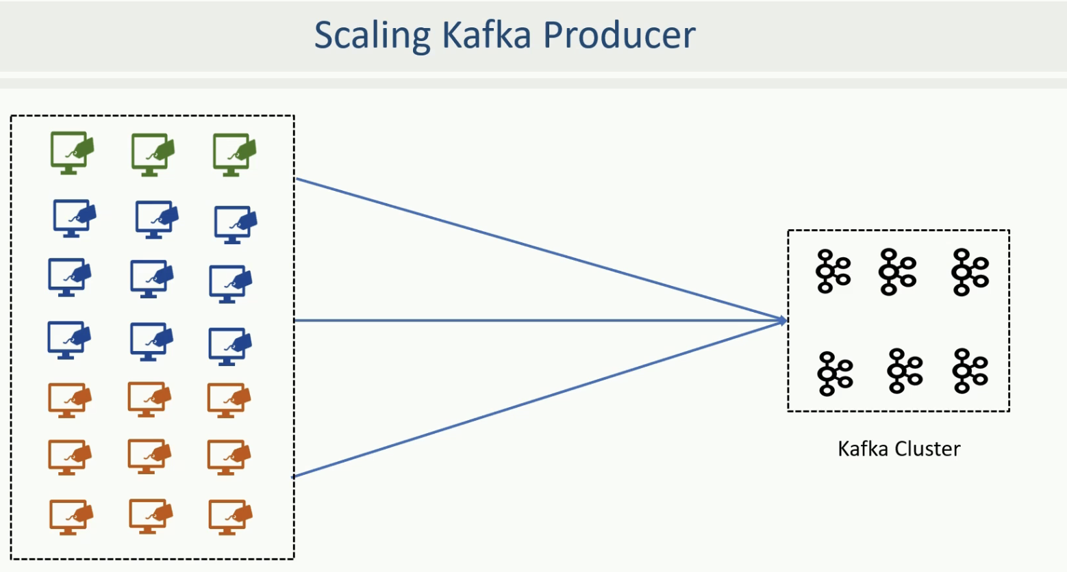

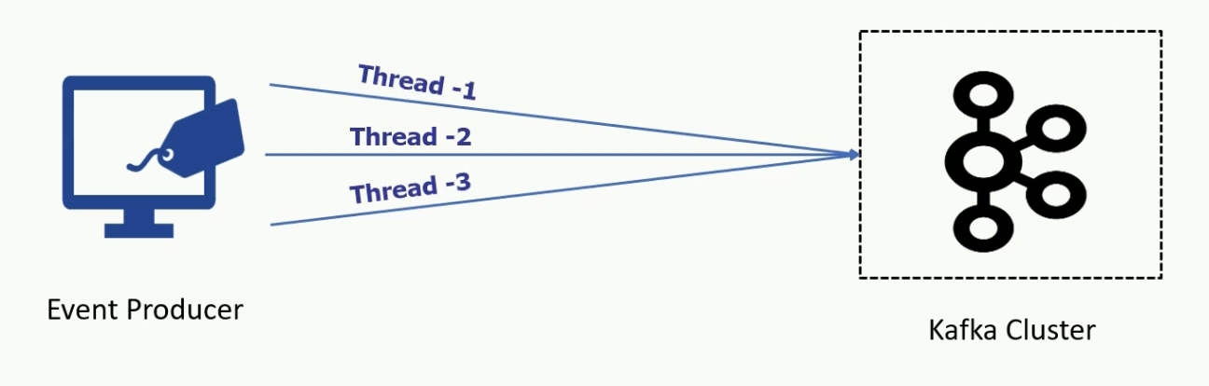

Welcome Back! In the earlier lectures, We created a very simple producer and sent one million short messages to the Kafka Server. But Kafka is all about scalability. In this lecture, we will explore some details about scaling up the producers. So, let's start. Apache Kafka was designed with the scalability in mind, and scaling a Kafka application is straightforward. If you consider the POS example, then each POS system can create a KafkaProducer object and send the invoices. The Figure here shows the scenario where multiple POS systems can send invoices in parallel. At the cluster end, it is the Kafka broker that receives the messages and acknowledges the successful receipt of the message. So, if you have hundreds of producers sending messages in parallel, you may want to increase the number of brokers in your Kafka cluster. A single Kafka broker can handle hundreds of messages or maybe thousands of messages per second. However, you can increase the number of Kafka brokers in your cluster and support hundreds of thousands of messages to be received and acknowledged. On the producer side, you can keep adding the new producers to send the messages to the Kafka server in parallel. This arrangement provides linear scalability by merely adding more producers and brokers. This approach works perfectly for scaling up your overall streaming bandwidth. However, you also have an opportunity to scale an individual producer using multithreading technique. A single producer thread is good enough to support the use cases where the data is being produced at a reasonable pace. However, some scenarios may require parallelism at the individual producer level as well. You can handle such requirements using multithreaded Kafka producer. The multithreading scenario may not apply to applications that do not frequently generate new messages. For example, an individual POS application would be producing an invoice every 2-3 minutes. In that case, a single thread is more than enough to send the invoices to the Kafka cluster. However, if you have an application that generates or receives data at high speed and wants to send it as quickly as possible, you might want to implement a multithreaded application. Great! See you again. Keep Learning and Keep Growing.

Apache Scaling:

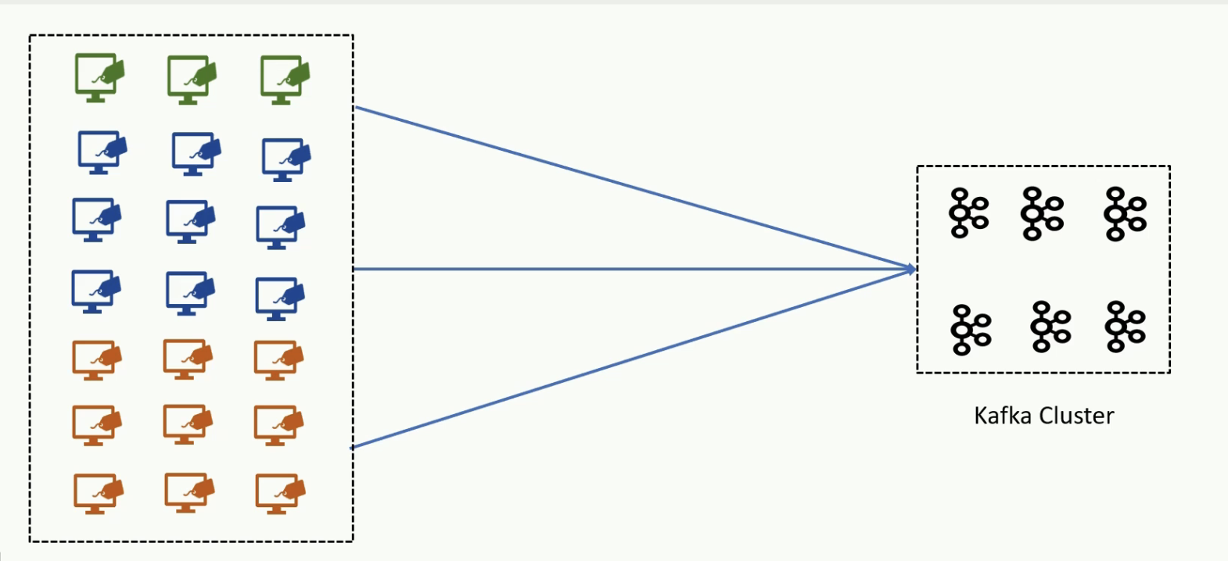

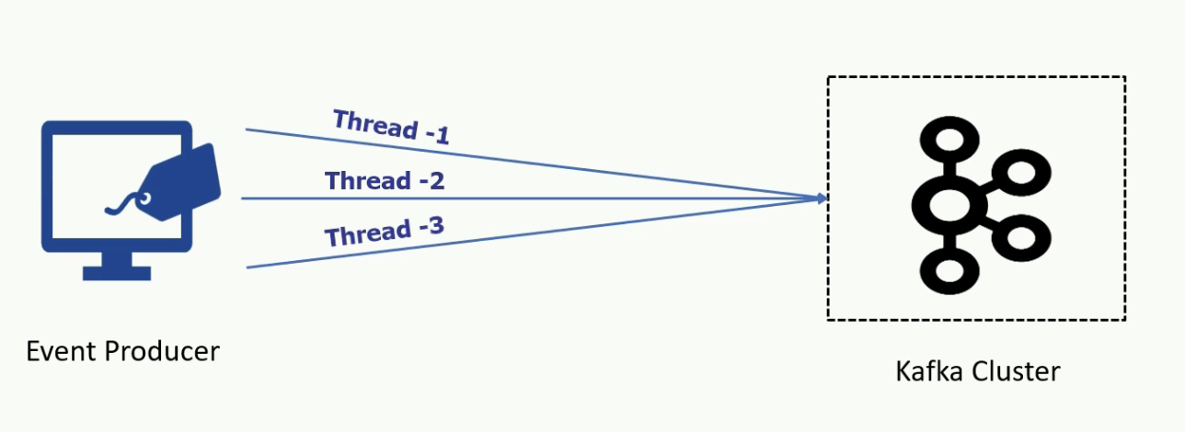

Welcome Back! In the earlier lectures, We created a very simple producer and sent one million short messages to the Kafka Server. But Kafka is all about scalability. In this lecture, we will explore some details about scaling up the producers. So, let's start. Apache Kafka was designed with the scalability in mind, and scaling a Kafka application is straightforward. If you consider the POS example, then each POS system can create a KafkaProducer object and send the invoices. The Figure here shows the scenario where multiple POS systems can send invoices in parallel. At the cluster end, it is the Kafka broker that receives the messages and acknowledges the successful receipt of the message. So, if you have hundreds of producers sending messages in parallel, you may want to increase the number of brokers in your Kafka cluster. A single Kafka broker can handle hundreds of messages or maybe thousands of messages per second. However, you can increase the number of Kafka brokers in your cluster and support hundreds of thousands of messages to be received and acknowledged. On the producer side, you can keep adding the new producers to send the messages to the Kafka server in parallel. This arrangement provides linear scalability by merely adding more producers and brokers. This approach works perfectly for scaling up your overall streaming bandwidth. However, you also have an opportunity to scale an individual producer using multithreading technique. A single producer thread is good enough to support the use cases where the data is being produced at a reasonable pace. However, some scenarios may require parallelism at the individual producer level as well. You can handle such requirements using multithreaded Kafka producer. The multithreading scenario may not apply to applications that do not frequently generate new messages. For example, an individual POS application would be producing an invoice every 2-3 minutes. In that case, a single thread is more than enough to send the invoices to the Kafka cluster. However, if you have an application that generates or receives data at high speed and wants to send it as quickly as possible, you might want to implement a multithreaded application. Great! See you again. Keep Learning and Keep Growing.

Multi Thread Usecase:

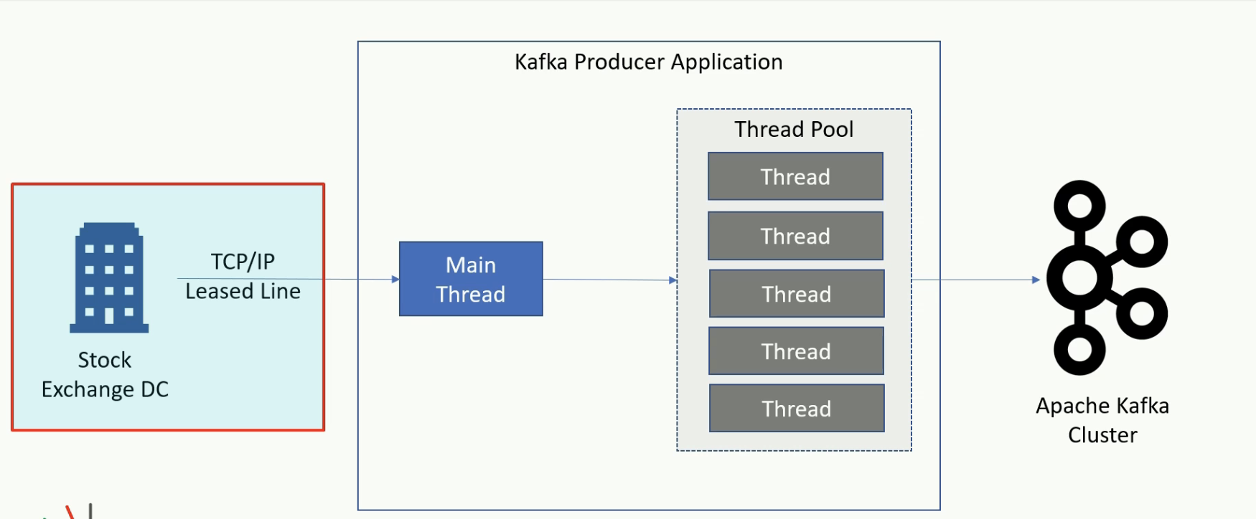

Welcome Back. Let's try to understand the need for multithreading with a realistic example. Let's assume a stock market data provider application, as shown in Figure. The application receives tick by tick stock data packets from the stock exchange over a TCP/IP socket. The data packets are arriving at high frequency. So, you decided to create a multithreaded data handler. The main thread listens to the Socket and reads the data packet as they arrive. The main thread immediately handovers the data packet to a different thread for sending the data to the Kafka broker and starts reading the next data packet. The other threads of the application are responsible for uncompressing the packet, reading individual messages from the data packet, validating the message, and sending it further to the Kafka broker. Similar scenarios are common in many other applications where the data arrives at high speed, and you may need multiple application threads to handle the load. Kafka producer is thread-safe. So, your application can share the same producer object across multiple threads and send messages in parallel using the same producer instance. It is not recommended to create numerous producer objects within the same application instance. Sharing the same producer across the threads will be faster and less resource intensive. Great! See you again. Keep Learning and Keep Growing

Atleast Once and At most Once:

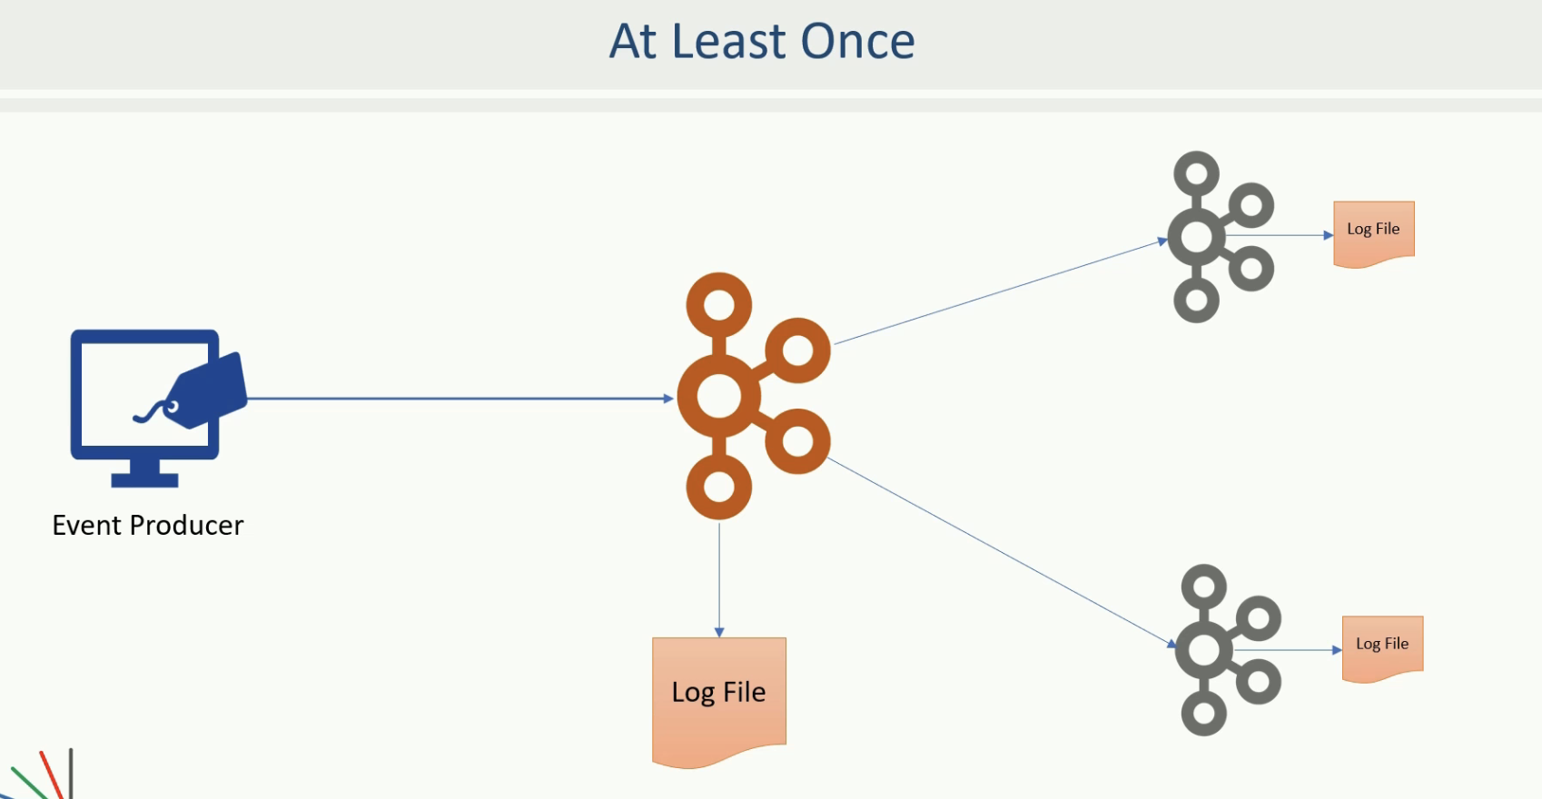

Welcome back. In the earlier lectures, you learned to create Kafka producers, and I am assuming that you are now comfortable in meeting most of the basic requirements of streaming events to the Kafka cluster. However, some specific and intricate scenarios require some extra attention. In this lecture, I will talk about some advanced producer concepts. Let's start. Apache Kafka provides message durability guaranties by committing the message at the partition log. The durability simply means, Once the data is persisted by the leader broker in the leader partition, we can't lose that message till the leader is alive. However, Â if the leader broker goes down, we may lose the data. To protect the loss of records due to leader failure, Kafka implements replication, right? Kafka implements replication using followers. The followers will copy messages from the leader and provide fault tolerance in case of leader failure. In other words, when the data is persisted to the leader as well as the followers in the ISR list, we consider the message to be fully committed. Once the message is fully committed, we can't lose the record until the leader, and all the replicas are lost, which is an unlikely case. However, in all this, we still have a possibility of committing duplicate messages Â due to the producer retry mechanism. As we learned in the earlier section, if the producer I/O thread fails to get a success acknowledgment from the broker, it will retry to send the same message. Now, assume that the I/O thread transmits a record to the broker. The broker receives the data and stores it into the partition log. The broker then sends an acknowledgment for the success, and the response does not reach back to the I/O thread due to a network error. In that case, the producer I/O thread will wait for the acknowledgment and ultimately send the record again assuming a failure. The broker again receives the data, but it doesn't have a mechanism to identify that the message is a duplicate of an earlier message. Hence, the broker saves the duplicate record causing a duplication problem. This implementation is known as at-least-once semantics, where we cannot lose messages because we are retrying until we get a success acknowledgment. However, we may have duplicates because we do not have a method to identify a duplicate message. For that reason, Kafka is said to provide at-least-once semantics. Kafka also allows you to implement at-most-once semantics. How? Well, that`s easy. You can achieve at-most-once by configuring the retires to zero. In that case, you may lose some records, but you will never have a duplicate record committed to Kafka logs. Great! See you again. Keep Learning and Keep Growing.

Exactly Once:

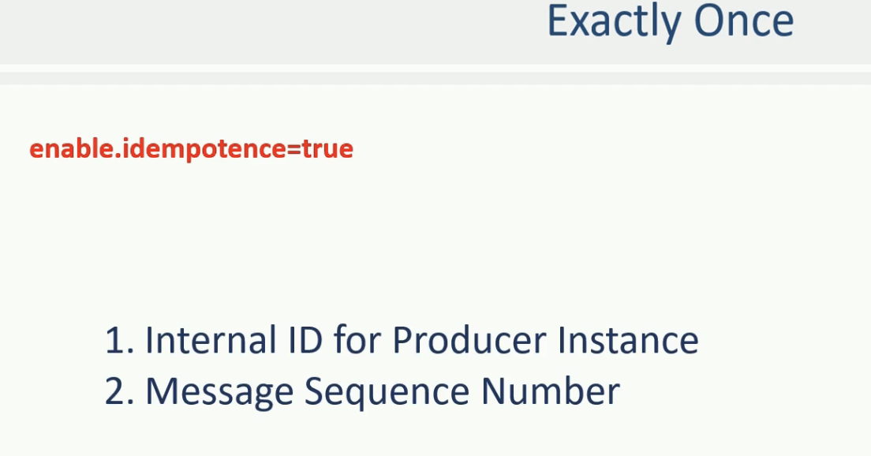

Welcome Back. We already learned that Kafka is at-least once system by default. And you can configure it to get at-most once. However, some use cases want to implement exactly-once semantics. I mean, we don't lose anything, and at the same time, we don't create duplicate records. To meet exactly once requirement, Kafka offers an idempotent producer configuration. All you need to do is to enable idempotence, and Kafka takes care of implementing exactly-once. To enable idempotence, you should set the enable.idempotence producer configuration to true. Â Once you configure the idempotence, the behavior of the producer API is changed. There are many things that happen internally, but at a high level, the producer API will do two things. It will perform an initial handshake with the leader broker and ask for a unique producer id. At the broker side, the broker dynamically assigns a unique ID to each producer. The next thing that happens is the message sequencing. The producer API will start assigning a sequence number to each message. This sequence number starts from zero and monotonically increments per partition. Now, when the I/O thread sends a message to a leader, the message is uniquely identified by the producer id and a sequence number. Now, the broker knows that the last committed message sequence number is X, and the next expected message sequence number is X+1. This allows the broker to identify duplicates as well as missing sequence numbers. So, setting enable.idempotence to true will help you ensure that the messages are neither lost not duplicated. How exactly it happens is not much relevant. We leave that on producer API and broker. All you need to do is to set the configuration to activate this behavior. However, you must always remember one thing. If you are sending duplicate messages at your application level, this configuration cannot protect you from duplicates. That should be considered as a bug in your application. Even if two different threads or two producer instances are sending duplicates, that too is an application design problem. The idempotence is only guaranteed for the producer retires. And you should not try to resend the messages at the application level. Idempotence is not guaranteed for the application level message resends. Or duplicates send by the application itself. Great! That's all for this lecture. Keep Learning and Keep Growing.

Kafka Consumer:

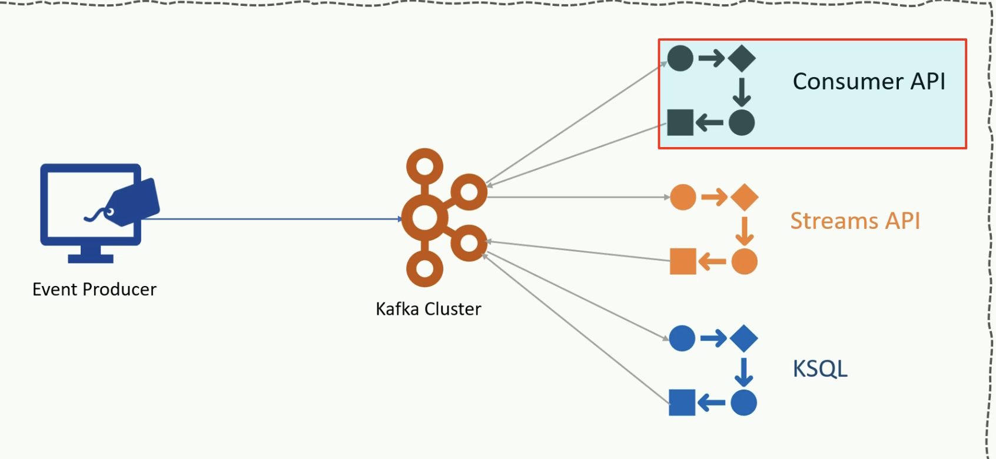

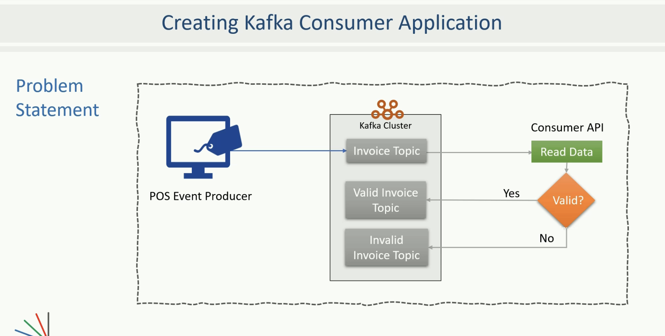

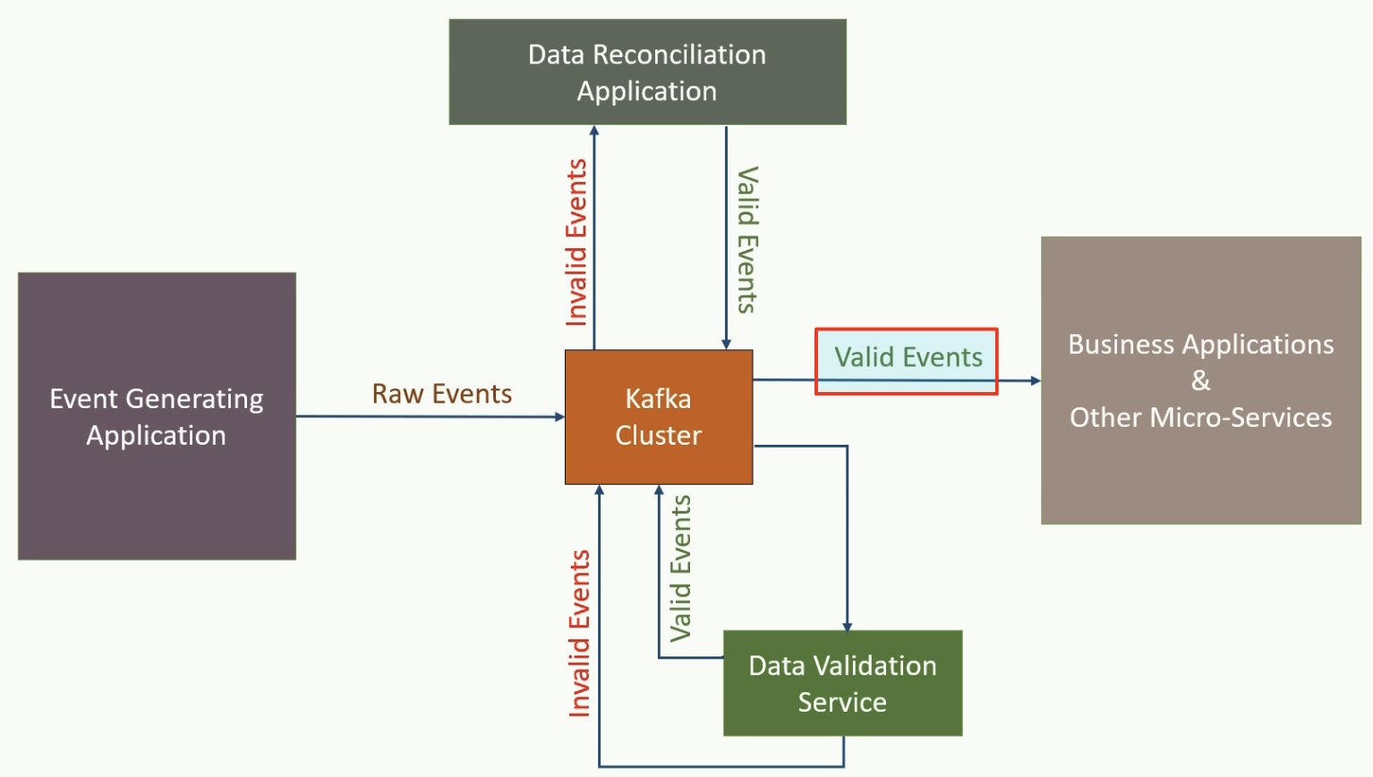

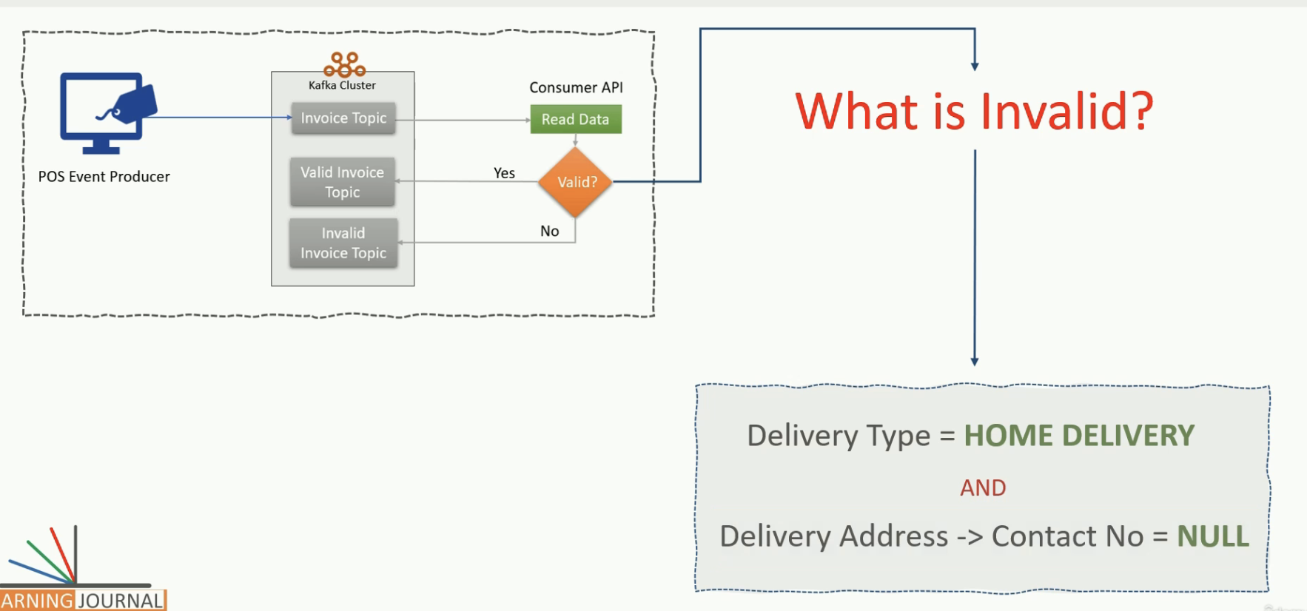

the consumer can start requesting the message records by making a call to the poll() method. The poll() method will immediately return an Iterable ConsumerRecords.

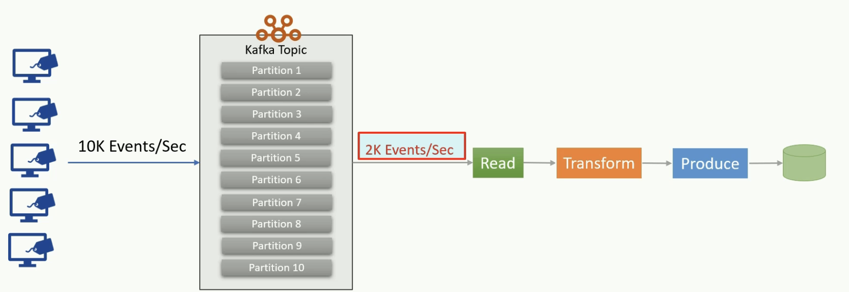

In the earlier lecture, we created a real-time data validation pipeline. Our application reads messages from a Kafka topic, run some validations against them, and write the valid and invalid messages in separate Kafka Topic. Instead of writing to Kafka topics, you can also write them to a database or any other kind of storage system. It is just a matter of changing a few lines of code. Right? In all such consume-transform-produce pipelines, your application will create a KafkaConsumer object, subscribe to the appropriate Topic, and start receiving messages, transforming them and writing the results. This process should be seamless. However, your application will begin falling behind, if the rate at which producers write messages to the Topic, exceeds the rate at which you can transform and write them to external storage. If you are limited to a single consumer reading and processing the data, your application may fall farther and farther behind and would no longer remain a real-time application. In this scenario, we need to scale consumption from topics. But the question is, How? How do we scale a consumer process? We can scale a consumer application by dividing the work among multiple consumers. Just like numerous producers can write to the same Topic, we need to allow various consumers to read from the same Topic. However, we also need a mechanism to split the data among the consumers, so they work with their own set of data and do not interfere with each other. How can you do that? This is where the topic partitions are handy. When we have multiple consumers working in a group and reading data from the same Topic, we can easily split the data among consumers by assigning them one or more partitions. In this arrangement, each consumer is attached with a set of Partitions, and they read data only from the assigned partitions. For example, if you have ten partitions in a topic, and there are two consumers in the same group reading data from the same Topic, Kafka would assign five partitions to each consumer. This arrangement clearly divides the data among the consumers to ensure that they do not read the same message. In this arrangement, every record is delivered to one and only one consumer in the group, and there is no duplicate processing. This arrangement also adds a restriction on the scalability Â Â Â that would be equal to the number of partitions in a given topic. For example, if you have ten partitions in a topic, you can add a maximum of ten consumers in a group, each assigned with a single partition to read. However, this limitation can be avoided by careful planning and creating enough number of partitions when we create a new topic. Now the next question is obvious. How can we create a consumer group and add new consumers in the same group? Do we also need to do something for assigning partitions to the consumers? Kafka offers automatic group management and rebalancing of the workload in a consumer group. All we need to do is to set the group id configuration. Kafka automatically forms a consumer group, Â Â Â and it would also add the consumer to the same group if they have the same group id. Kafka will also take care of assigning partitions to the consumer in the same group. Membership in a consumer group is maintained dynamically. If a consumer fails, the partitions assigned to it will be reassigned to other consumers in the same group. Similarly, if a new consumer joins the group, partitions will be moved from existing consumers to the new one to maintain the workload balance. Conceptually, you can think of a consumer group as being a single logical consumer that happens to be made up of multiple processes sharing the workload. Kafka automatically manages all of this, and the whole process is transparent to users. You, as a programmer is responsible for setting the group id configuration and starting a new consumer process either on the same machine or on a separate computer. Great! See you again Keep Learning and Keep Growing.

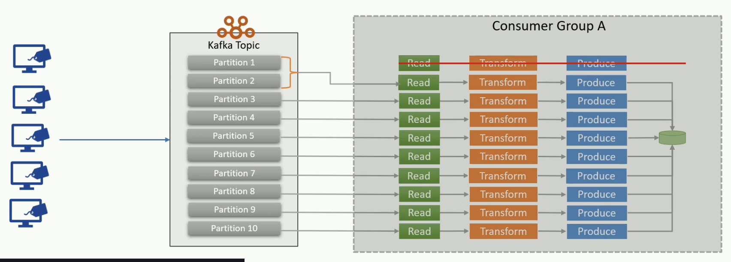

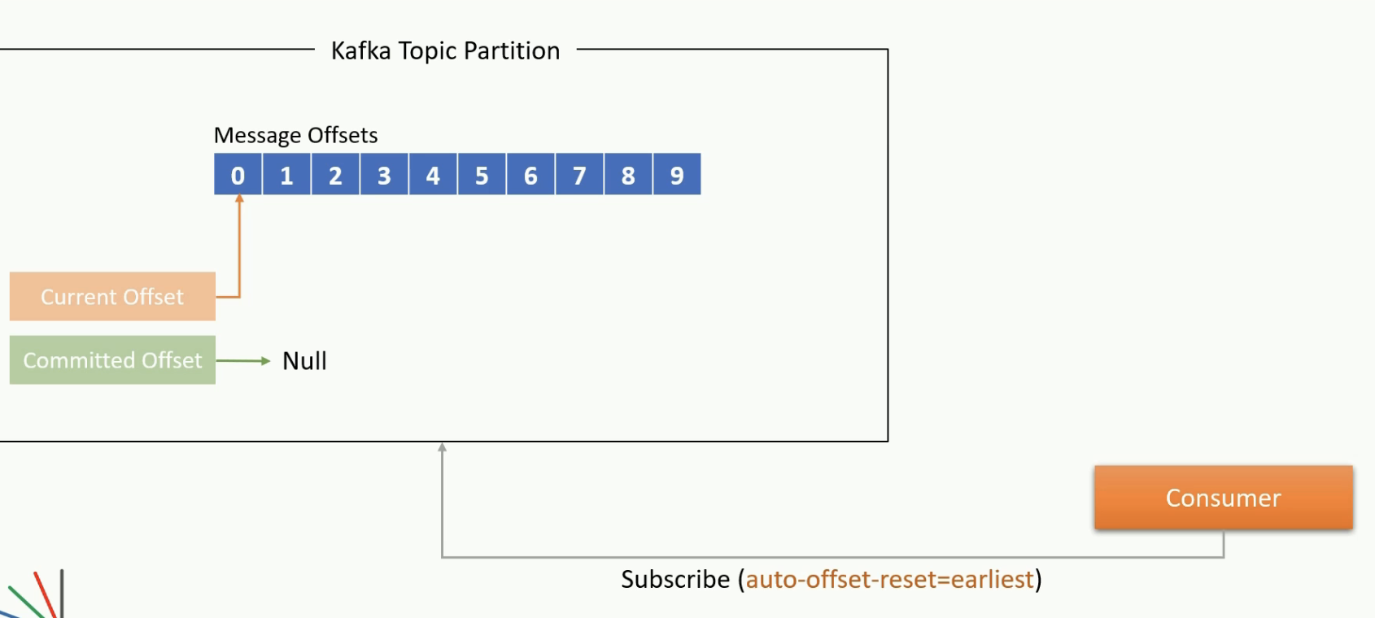

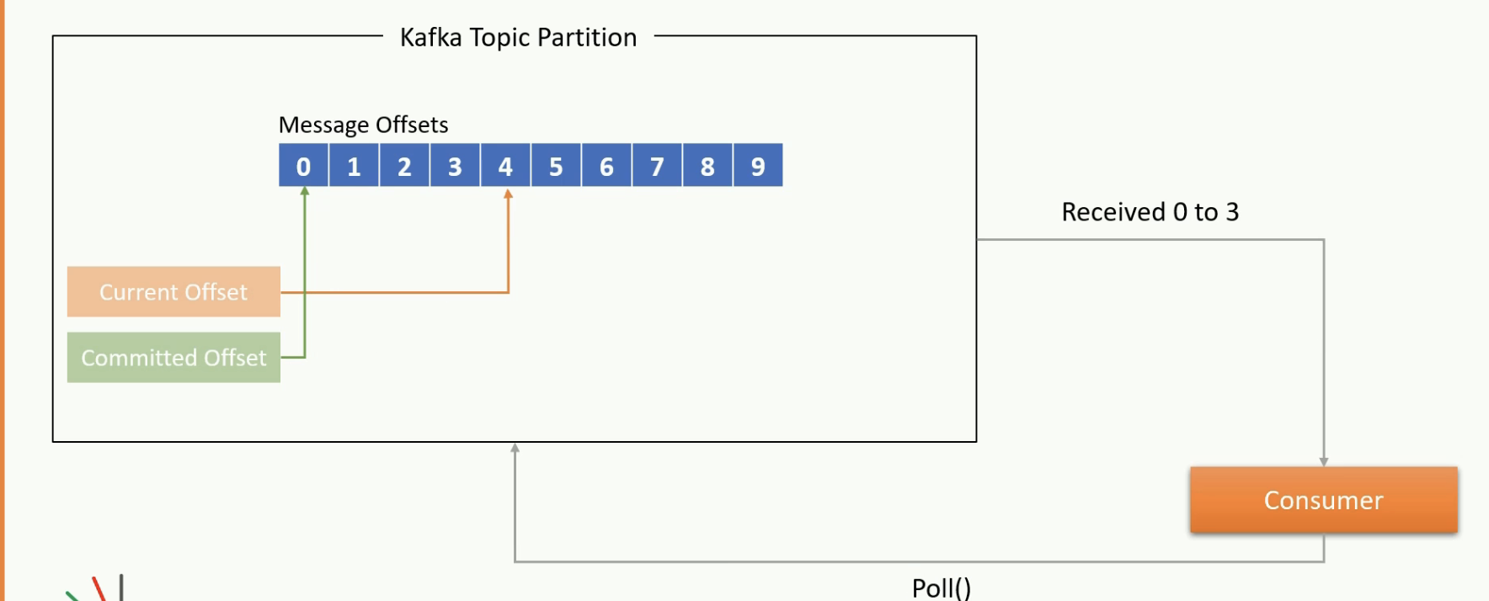

Welcome Back. So, the problem of scalability for the consumers is taken care of by the consumer groups. The issue of fault tolerance is also taken care of by the rebalancing within the consumer groups. Right? However, we still have an open question. Assume that the partition was initially assigned to a consumer. The consumer processed some messages for a while and crashed. Kafka automatic rebalancing will detect the failure of the consumer and reassign the unattended partition to some other consumer in the group. This is where we gat a new doubt. The new consumer should not reprocess the events that are already processed by the earlier consumer before it failed. Right? How would Kafka handle this? Let's try to understand. We already learned in earlier videos that an offset uniquely identifies every message in a partition. Kafka also maintains two offset positions for each partition. Current offset position and Committed offset position. These positions are maintained for the consumer. The Current offset position of the consumer is the offset of the next record that will be given out to the consumer for the next poll(). In the beginning, the current offset might be unknown or null for a new consumer subscription. In that case, you can set the auto-offset-reset configuration to the earliest or latest. If you set to earliest, then Kafka will set the current offset position to the first record in the partition and start giving you all the messages from the beginning. Otherwise, the default value is the latest, which will send you only upcoming messages after the consumer subscribed and ignore all earlier messages. This all happens only in the beginning when the current-offset, as well as the committed-offset, is undefined. Once the initial current-offset is determined, it automatically advances every time you poll() some messages. The current offset is persistent to the consumer session. If the consumer fails or restarts, then the current offset is determined once again. For that reason, if you restart a consumer after a failure, you may start getting the records once again that were already sent in the earlier session. To avoid that situation, Kafka also maintains a committed offset position. Every time you poll(), the consumer will automatically commit the earlier current-offset and send some more records. These new records are then automatically committed by the next poll(). This mechanism is known as auto-commit. The committed offset position is the last offset that has been stored securely at the broker. So, when the consumer process fails and restarts, or the partition is reassigned to some other consumer in the group, the committed offset is used to override the current offset position for the consumer. So, in summary, the committed offset is securely stored with the broker. When a consumer restart or the partition is reassigned to another consumer, Â the committed-offset is used to avoid duplicate processing. And all this happens automatically in most of the cases. But you also have options to take control in your hand and do it manually using commit APIs. The current offset is determined as latest or earliest only when there is no committed offset. Otherwise, the committed-offset is used to set the current offset. Great! See you again Keep Learning and Keep Growing